What is Spring JDBC | Introduct to Spring JDBC | Why to use Spring JDBC

Spring JDBC is a module in the Spring Framework that simplifies working with relational databases using JDBC (Java Database Connectivity). It provides an abstraction layer over the standard JDBC API, making it easier to interact with databases while managing resources like connections and statements.
Spring JDBC addresses the boilerplate code and common errors developers face when using raw JDBC. It includes features like:
- Automatic resource management.
- Exception translation into more meaningful exceptions.
- Simplified data access using templates.

Introduction to Spring JDBC
- Core Component: Spring JDBC is part of the Spring Data Access Framework, which includes other modules like JPA and ORM.
- Template-Based Approach: It primarily uses the JdbcTemplate class, which provides a simplified API to execute SQL queries, updates, and more.
- Integration with Spring: It works seamlessly with other Spring features, like dependency injection and transaction management.

Why Use Spring JDBC?

1. Simplifies JDBC Development
- Eliminates boilerplate code like opening/closing connections, preparing statements, and handling exceptions.
- Example (Without Spring JDBC):
java
Copy code
Connection conn = null;
PreparedStatement stmt = null;
try {
conn = DriverManager.getConnection("jdbc:mysql://localhost:3306/testdb", "user", "password");
stmt = conn.prepareStatement("SELECT * FROM students");
ResultSet rs = stmt.executeQuery();
while (rs.next()) {
System.out.println(rs.getString("name"));
}
} catch (SQLException e) {
e.printStackTrace();
} finally {
if (stmt != null) stmt.close();
if (conn != null) conn.close();
}
With Spring JDBC:
java
Copy code
JdbcTemplate jdbcTemplate = new JdbcTemplate(dataSource);
String sql = "SELECT name FROM students";
List<String> names = jdbcTemplate.query(sql, (rs, rowNum) -> rs.getString("name"));
names.forEach(System.out::println);

2. Automatic Resource Management
- Spring JDBC automatically closes database resources (connections, statements, result sets) after use, avoiding memory leaks.

3. Consistent Exception Handling
- Translates SQLException into more user-friendly, meaningful exceptions (e.g., DataAccessException).

4. Better Code Readability and Maintainability
- Reduces clutter by abstracting repetitive code, making the codebase cleaner and easier to maintain.

5. Integration with Spring Features
- Works seamlessly with Spring’s transaction management.
- Supports dependency injection for the DataSource and JdbcTemplate objects.

6. Efficient Query Execution
- Provides utility methods for common tasks like batch processing, querying, and parameter binding.

Key Classes and Interfaces in Spring JDBC
- JdbcTemplate:
  - Core class to execute queries, updates, and call stored procedures.
- NamedParameterJdbcTemplate:
  - Variant of JdbcTemplate that allows using named parameters instead of positional placeholders.
- RowMapper<T>:
  - Interface for mapping rows of a ResultSet to Java objects.
- DataSource:
  - Interface for obtaining connections to a database. Can be configured with Spring.

When to Use Spring JDBC?
- When you want full control over SQL queries but want to avoid the repetitive code of plain JDBC.
- When working on projects with simple or moderately complex data access requirements.
- When using a relational database but not a heavy ORM framework like Hibernate or JPA.

Conclusion
Spring JDBC is a lightweight and flexible abstraction over the traditional JDBC API. It simplifies database access, improves code quality, and integrates well with other Spring modules, making it ideal for applications that require efficient and clean interaction with relational databases.
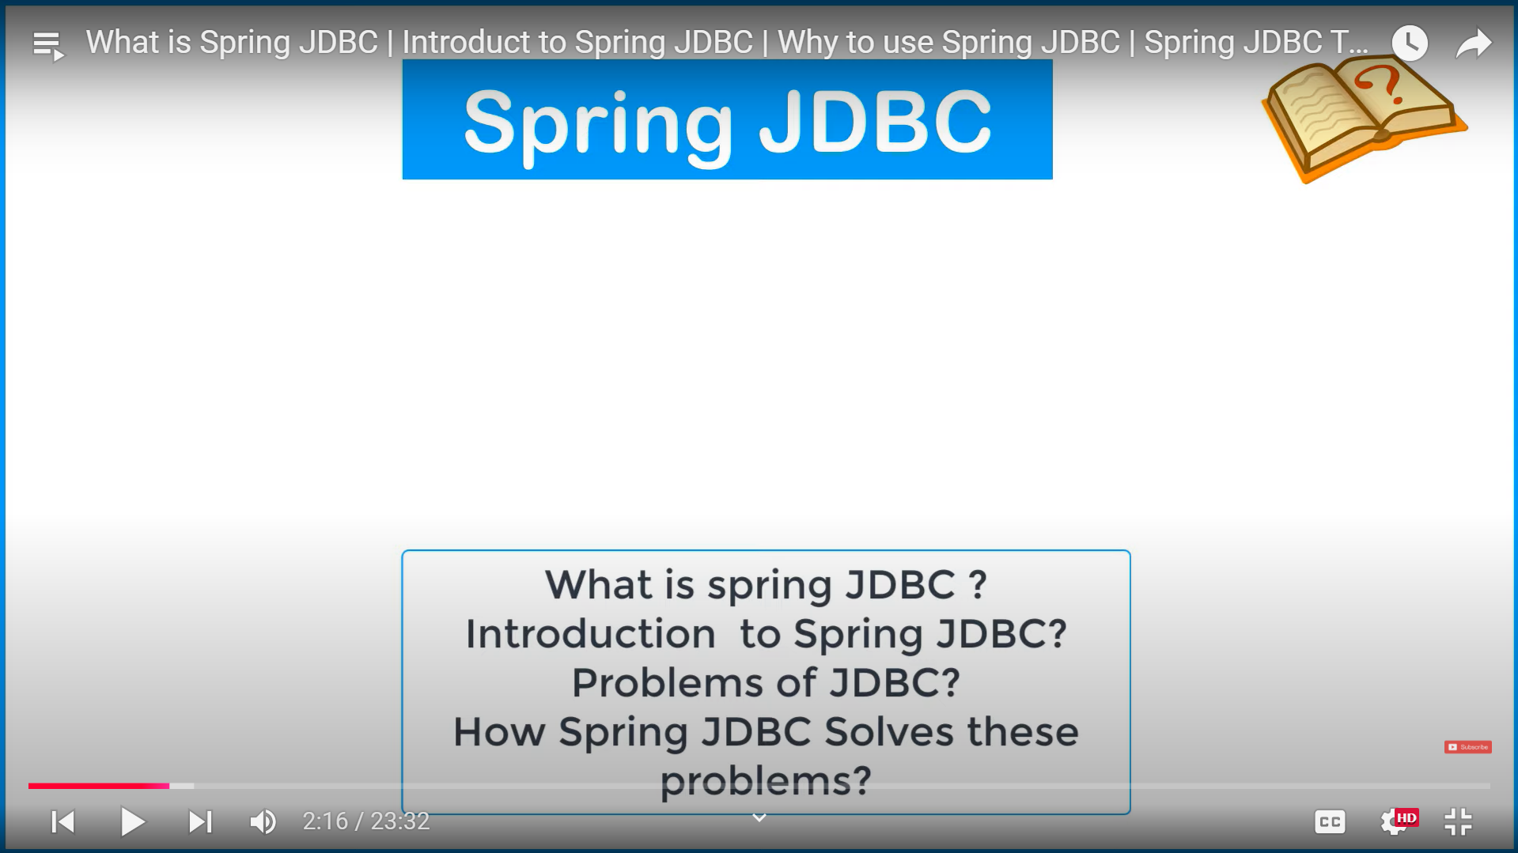
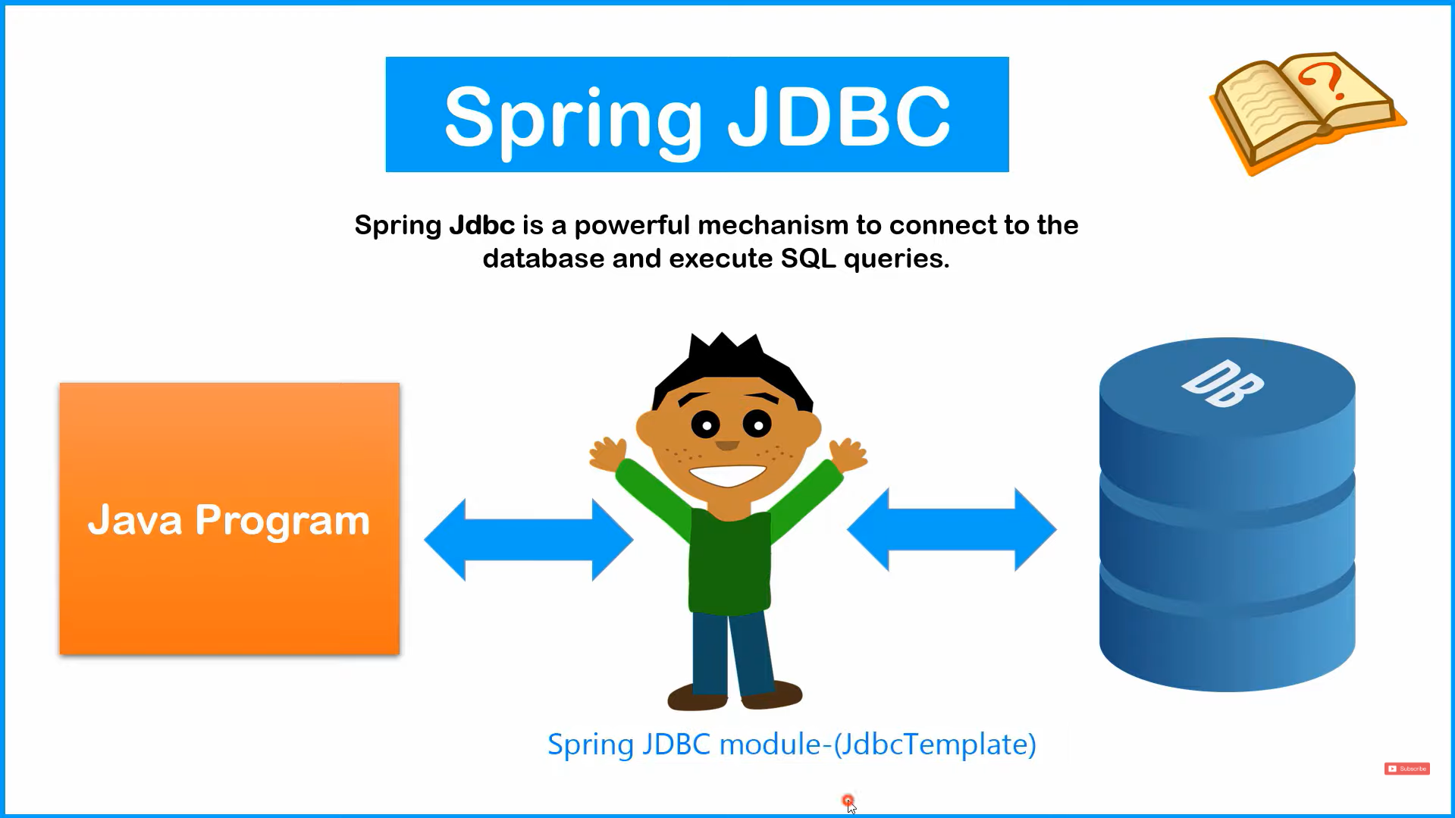
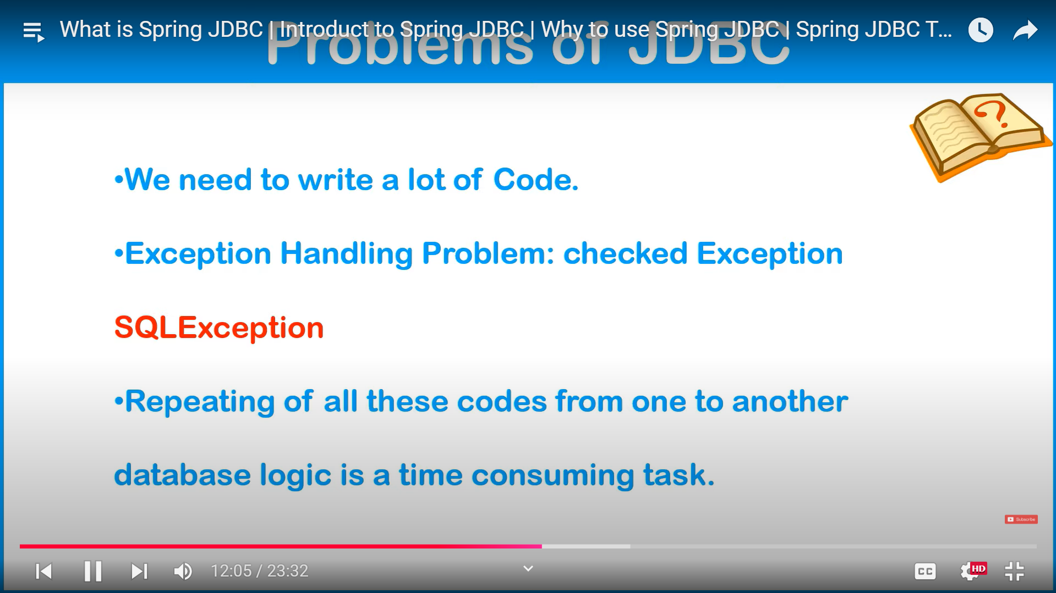
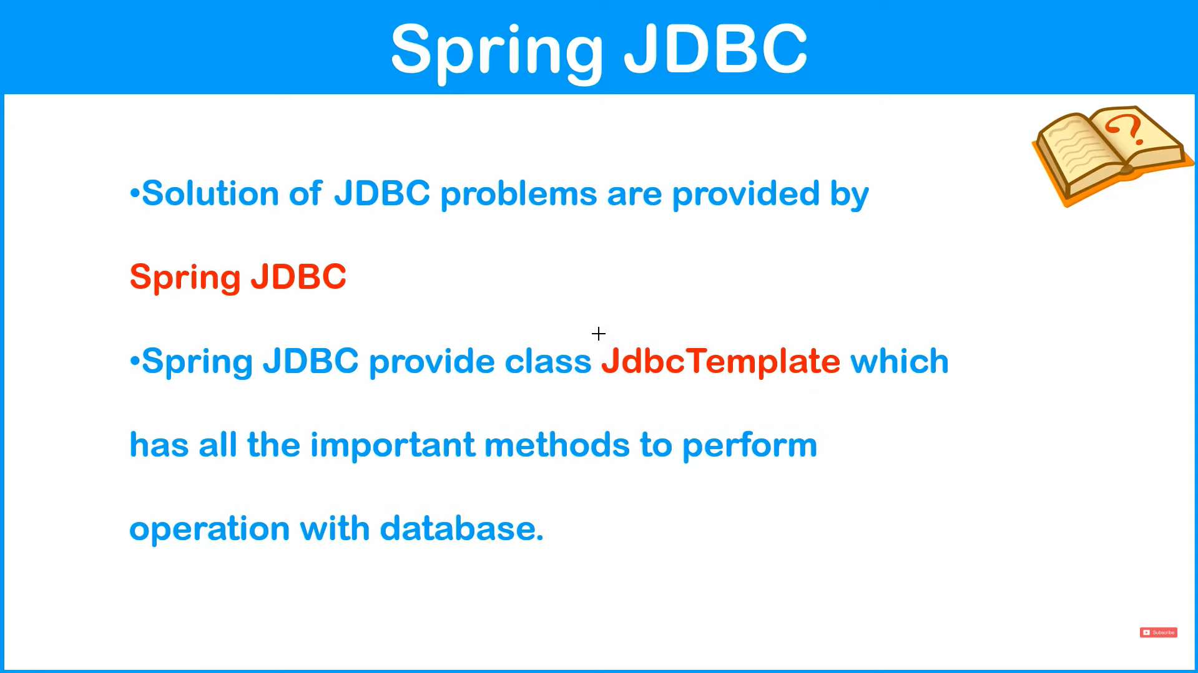
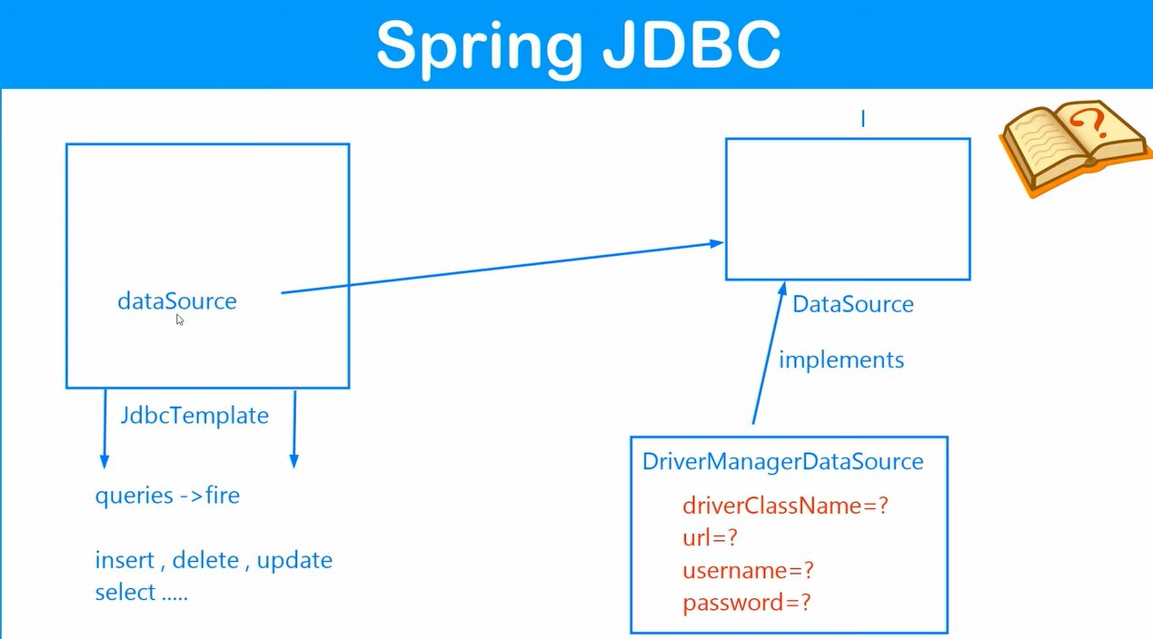
Database setup | Configuring Jdbc Template to execute query

Configuring JdbcTemplate in Spring to execute a query involves setting up a DataSource for database connection and defining a JdbcTemplate bean. Here's a step-by-step explanation:

1. Add Spring JDBC Dependency
In your Maven project, include the Spring JDBC dependency:
xml
Copy code
<dependency>
<groupId>org.springframework</groupId>
<artifactId>spring-jdbc</artifactId>
<version>5.3.30</version>
</dependency>

2. Set up Database Connection in application.properties
Add database configurations for PostgreSQL (or any DB you're using) in the application.properties file:
properties
Copy code
spring.datasource.url=jdbc:postgresql://localhost:5432/spring
spring.datasource.username=your_username
spring.datasource.password=your_password
spring.datasource.driver-class-name=org.postgresql.Driver

3. Java Configuration
You can use a @Configuration class to define the JdbcTemplate and DataSource.

Example:
java
Copy code
import org.springframework.context.annotation.Bean;
import org.springframework.context.annotation.Configuration;
import org.springframework.jdbc.core.JdbcTemplate;
import org.springframework.jdbc.datasource.DriverManagerDataSource;

import javax.sql.DataSource;

@Configuration
public class JdbcConfig {

@Bean
public DataSource dataSource() {
DriverManagerDataSource dataSource = new DriverManagerDataSource();
dataSource.setDriverClassName("org.postgresql.Driver");
dataSource.setUrl("jdbc:postgresql://localhost:5432/spring");
dataSource.setUsername("your_username");
dataSource.setPassword("your_password");
return dataSource;
}

@Bean
public JdbcTemplate jdbcTemplate(DataSource dataSource) {
return new JdbcTemplate(dataSource);
}
}

4. Use JdbcTemplate to Execute a Query
You can use the JdbcTemplate in a service or DAO class to interact with the database.

Example Service:
java
Copy code
import org.springframework.beans.factory.annotation.Autowired;
import org.springframework.jdbc.core.JdbcTemplate;
import org.springframework.stereotype.Service;

@Service
public class StudentService {

@Autowired
private JdbcTemplate jdbcTemplate;

public void insertStudent(int id, String name, String city) {
String sql = "INSERT INTO student (id, name, city) VALUES (?, ?, ?)";
jdbcTemplate.update(sql, id, name, city);
System.out.println("Student inserted successfully!");
}

public void fetchStudents() {
String sql = "SELECT * FROM student";
jdbcTemplate.query(sql, (rs, rowNum) -> {
System.out.println("ID: " + rs.getInt("id") + ", Name: " + rs.getString("name") +
", City: " + rs.getString("city"));
return null;
});
}
}

5. Run the Application
Create a main class with @SpringBootApplication annotation or call the service methods in your existing setup.

Example Main Class:
java
Copy code
import org.springframework.beans.factory.annotation.Autowired;
import org.springframework.boot.CommandLineRunner;
import org.springframework.boot.SpringApplication;
import org.springframework.boot.autoconfigure.SpringBootApplication;

@SpringBootApplication
public class SpringJdbcApplication implements CommandLineRunner {

@Autowired
private StudentService studentService;

public static void main(String[] args) {
SpringApplication.run(SpringJdbcApplication.class, args);
}

@Override
public void run(String... args) throws Exception {
studentService.insertStudent(1, "Yash", "Thane");
studentService.fetchStudents();
}
}

Key Notes:
- Use JdbcTemplate#update for INSERT, UPDATE, or DELETE queries.
- Use JdbcTemplate#query or queryForObject for SELECT queries.
- In Spring Boot, JdbcTemplate can be auto-configured if spring-boot-starter-jdbc is added. You can simply inject it using @Autowired.
This approach centralizes configuration and uses the power of Spring's dependency injection.
4o

he issue arises because the batchUpdate method of JdbcTemplate is not designed to accept parameters directly in the way you've provided. Instead, it expects a Collection of objects and a ParameterizedPreparedStatementSetter or a simpler BatchPreparedStatementSetter to handle multiple records.
Here’s how you can fix your code to batch-insert students:

Correct Usage of batchUpdate
java
Copy code
// Prepare a list of students to batch insert
List<Student> students = Arrays.asList(
new Student(1, "Yash", "Thane"),
new Student(2, "Rahul", "Pune"),
new Student(3, "Anjali", "Mumbai")
);

// Define the SQL query
String query = "INSERT INTO student(id, name, city) VALUES(?, ?, ?)";

// Use batchUpdate with a BatchPreparedStatementSetter
this.jdbcTemplate.batchUpdate(query, new BatchPreparedStatementSetter() {
@Override
public void setValues(PreparedStatement ps, int i) throws SQLException {
Student student = students.get(i);
ps.setInt(1, student.getId());
ps.setString(2, student.getName());
ps.setString(3, student.getCity());
}

@Override
public int getBatchSize() {
return students.size();
}
});

Explanation
- BatchPreparedStatementSetter:
  - Provides methods to set values for each row in the batch (setValues) and the size of the batch (getBatchSize).
  - The setValues method is called for each record in the students list.
- Why batchUpdate?:
  - It’s optimized for inserting/updating multiple rows in a single database call, improving performance over multiple individual update calls.
- Steps:
  - Create a collection of student objects.
  - Use batchUpdate and implement BatchPreparedStatementSetter to set the values for each student.

If You’re Not Using a Batch (Single Insert for One Student)
For a single student insertion (non-batch):
java
Copy code
String query = "INSERT INTO student(id, name, city) VALUES(?, ?, ?)";
this.jdbcTemplate.update(query, student.getId(), student.getName(), student.getCity());
Let me know if you have more questions!

First using Simple
Config.xml
<?xml version="1.0" encoding="UTF-8"?>
<beans xmlns="http://www.springframework.org/schema/beans"
xmlns:xsi="http://www.w3.org/2001/XMLSchema-instance"
xmlns:context="http://www.springframework.org/schema/context"
xmlns:p="http://www.springframework.org/schema/p"
xmlns:util="http://www.springframework.org/schema/util"
xsi:schemaLocation="http://www.springframework.org/schema/beans
http://www.springframework.org/schema/beans/spring-beans.xsd
http://www.springframework.org/schema/context
http://www.springframework.org/schema/context/spring-context.xsd
http://www.springframework.org/schema/util
http://www.springframework.org/schema/util/spring-util.xsd">
<bean class="org.springframework.jdbc.datasource.DriverManagerDataSource" name="ds">
<property name="driverClassName" value="org.postgresql.Driver"></property>
<property name="url" value="jdbc:postgresql://localhost:5432/spring"></property>
<property name="username" value="postgres"></property>
<property name="password" value="light"></property>
</bean>
<bean class="org.springframework.jdbc.core.JdbcTemplate" name="jdbcTemplate">
<property name="dataSource"><ref bean="ds" />

</property>
</bean>
<bean class="com.spring.jdbc.dao.StudentImp" name="StudentDao">
<property name="JdbcTemplate" ref="jdbcTemplate"></property>

</bean>
</beans>

App.java
package com.spring.jdbc;

import org.springframework.context.ApplicationContext;
import org.springframework.context.support.ClassPathXmlApplicationContext;
import org.springframework.jdbc.core.JdbcTemplate;

/**
* Hello world!
*
*/
public class App
{
public static void main( String[] args )
{
System.out.println( "..................Hello Project is Started................!" );
System.out.println("=======================================================================");

//spring jdbc jdbc tempate
ApplicationContext context = new ClassPathXmlApplicationContext("com/spring/jdbc/config.xml");
JdbcTemplate template = context.getBean("jdbcTemplate",JdbcTemplate.class );
//insert query
String query="insert into student(id,name,city) values(?,?,?)";
int result= template.update(query,29,"Tanmay","Airoli");
System.out.println("Number of records inserted : "+ result);
System.out.println("=======================================================================");

//insert query
String query1="insert into student(id,name,city) values(?,?,?)";
int result1= template.update(query,31,"Topya","Bhagur");
System.out.println("Number of records inserted : "+ result1);

System.out.println("=======================================================================");

//insert query
String query2="insert into student(id,name,city) values(?,?,?)";
int result2= template.update(query,30,"Burgandy","Murgud");
System.out.println("Number of records inserted : "+ result2);
System.out.println("=======================================================================");

}
}

Student.java
package com.spring.jdbc.entities;

public class Student {
private int id;
private String name;
private String city;
public Student() {
super();
// TODO Auto-generated constructor stub
}
public Student(int id, String name, String city) {
super();
this.id = id;
this.name = name;
this.city = city;
}
public int getId() {
return id;
}
public void setId(int id) {
this.id = id;
}
public String getName() {
return name;
}
public void setName(String name) {
this.name = name;
}
public String getCity() {
return city;
}
public void setCity(String city) {
this.city = city;
}
@Override
public String toString() {
return "Student [id=" + id + ", name=" + name + ", city=" + city + ", getId()=" + getId() + ", getName()="
+ getName() + ", getCity()=" + getCity() + ", getClass()=" + getClass() + ", hashCode()=" + hashCode()
+ ", toString()=" + super.toString() + "]";
}

}

Now we will create and interface and implements it the xml remains same as we added already that class
Intercae.java
package com.spring.jdbc.dao;

import com.spring.jdbc.entities.Student;

public interface StudentDao {
public int insert(Student student);

}

Java class implement it is
package com.spring.jdbc.dao;

import org.springframework.jdbc.core.JdbcTemplate;

import com.spring.jdbc.entities.Student;

public class StudentImp implements StudentDao {
private JdbcTemplate jdbcTemplate ;

@Override
public int insert(Student student) {
// TODO Auto-generated method stub
//insert query
String query1="insert into student(id,name,city) values(?,?,?)";
int r = this.jdbcTemplate.update(query1,student.getId(),student.getName(),student.getCity());
return r;
}

public JdbcTemplate getJdbcTemplate() {
return jdbcTemplate;
}

public void setJdbcTemplate(JdbcTemplate jdbcTemplate) {
this.jdbcTemplate = jdbcTemplate;
}

@Override
public String toString() {
return "StudentImp [jdbcTemplate=" + jdbcTemplate + ", getJdbcTemplate()=" + getJdbcTemplate() + ", getClass()="
+ getClass() + ", hashCode()=" + hashCode() + ", toString()=" + super.toString() + "]";
}

public StudentImp(JdbcTemplate jdbcTemplate) {
super();
this.jdbcTemplate = jdbcTemplate;
}

public StudentImp() {
super();
// TODO Auto-generated constructor stub
}

}

Now to run it app.java as usual
package com.spring.jdbc;
import org.springframework.context.ApplicationContext;
import org.springframework.context.support.ClassPathXmlApplicationContext;
import org.springframework.jdbc.core.JdbcTemplate;

import com.spring.jdbc.dao.StudentDao;
import com.spring.jdbc.entities.Student;

public class Apps {

public static void main(String[] args) {
// TODO Auto-generated method stub

System.out.println("My Program started........");
// Spring JDBC => JdbcTemplate
ApplicationContext context = new ClassPathXmlApplicationContext("com/spring/jdbc/config.xml");

StudentDao studentDao = context.getBean("StudentDao", StudentDao.class);

Student student = new Student();
student.setId(118);
student.setName("King Kohli");
student.setCity("Delhi");

int result = studentDao.insert(student);

System.out.println("Student added " + result + student);
}

}

THIS WAS ALL TO INSERT DATA
Now will see update

Update Operation using Spring Jdbc | Spring Jdbc Tutorial
Here's a complete explanation and example for performing update operations using Spring JDBC with both XML-based configuration and Annotation-based configuration. We'll cover single updates as well as batch updates.

1. Single Update with XML Configuration

Configuration (XML)
xml
Copy code
<beans xmlns="http://www.springframework.org/schema/beans"
xmlns:xsi="http://www.w3.org/2001/XMLSchema-instance"
xsi:schemaLocation="http://www.springframework.org/schema/beans
http://www.springframework.org/schema/beans/spring-beans.xsd">

<!-- DataSource Bean -->
<bean id="dataSource" class="org.springframework.jdbc.datasource.DriverManagerDataSource">
<property name="driverClassName" value="org.postgresql.Driver" />
<property name="url" value="jdbc:postgresql://localhost:5432/spring" />
<property name="username" value="postgres" />
<property name="password" value="password" />
</bean>

<!-- JdbcTemplate Bean -->
<bean id="jdbcTemplate" class="org.springframework.jdbc.core.JdbcTemplate">
<property name="dataSource" ref="dataSource" />
</bean>

<!-- StudentDao Bean -->
<bean id="studentDao" class="com.example.dao.StudentDaoImpl">
<property name="jdbcTemplate" ref="jdbcTemplate" />
</bean>
</beans>

DAO Implementation
java
Copy code
public class StudentDaoImpl implements StudentDao {
private JdbcTemplate jdbcTemplate;

// Setter for JdbcTemplate
public void setJdbcTemplate(JdbcTemplate jdbcTemplate) {
this.jdbcTemplate = jdbcTemplate;
}

@Override
public int updateStudent(Student student) {
String query = "UPDATE student SET name = ?, city = ? WHERE id = ?";
return jdbcTemplate.update(query, student.getName(), student.getCity(), student.getId());
}
}

Main Class
java
Copy code
public static void main(String[] args) {
ApplicationContext context = new ClassPathXmlApplicationContext("config.xml");

StudentDao studentDao = context.getBean("studentDao", StudentDao.class);

Student student = new Student();
student.setId(101);
student.setName("Updated Name");
student.setCity("Updated City");

int result = studentDao.updateStudent(student);

System.out.println("Number of rows updated: " + result);
}

2. Single Update with Annotations

Configuration with Annotations
java
Copy code
@Configuration
@ComponentScan(basePackages = "com.example")
public class AppConfig {

@Bean
public DataSource dataSource() {
DriverManagerDataSource dataSource = new DriverManagerDataSource();
dataSource.setDriverClassName("org.postgresql.Driver");
dataSource.setUrl("jdbc:postgresql://localhost:5432/spring");
dataSource.setUsername("postgres");
dataSource.setPassword("password");
return dataSource;
}

@Bean
public JdbcTemplate jdbcTemplate(DataSource dataSource) {
return new JdbcTemplate(dataSource);
}
}

DAO Implementation
java
Copy code
@Repository
public class StudentDaoImpl implements StudentDao {

@Autowired
private JdbcTemplate jdbcTemplate;

@Override
public int updateStudent(Student student) {
String query = "UPDATE student SET name = ?, city = ? WHERE id = ?";
return jdbcTemplate.update(query, student.getName(), student.getCity(), student.getId());
}
}

Main Class
java
Copy code
public static void main(String[] args) {
ApplicationContext context = new AnnotationConfigApplicationContext(AppConfig.class);

StudentDao studentDao = context.getBean(StudentDao.class);

Student student = new Student();
student.setId(102);
student.setName("Updated John");
student.setCity("Updated Lucknow");

int result = studentDao.updateStudent(student);

System.out.println("Number of rows updated: " + result);
}

3. Batch Update

Batch Update Logic
Batch updates allow multiple rows to be updated in a single execution for better performance.

DAO Implementation
java
Copy code
public class StudentDaoImpl implements StudentDao {

@Autowired
private JdbcTemplate jdbcTemplate;

@Override
public int[] batchUpdateStudents(List<Student> students) {
String query = "UPDATE student SET name = ?, city = ? WHERE id = ?";

return jdbcTemplate.batchUpdate(query, new BatchPreparedStatementSetter() {
@Override
public void setValues(PreparedStatement ps, int i) throws SQLException {
Student student = students.get(i);
ps.setString(1, student.getName());
ps.setString(2, student.getCity());
ps.setInt(3, student.getId());
}

@Override
public int getBatchSize() {
return students.size();
}
});
}
}

Main Class for Batch Update
java
Copy code
public static void main(String[] args) {
ApplicationContext context = new AnnotationConfigApplicationContext(AppConfig.class);

StudentDao studentDao = context.getBean(StudentDao.class);

List<Student> students = new ArrayList<>();
students.add(new Student(101, "Batch Name 1", "Batch City 1"));
students.add(new Student(102, "Batch Name 2", "Batch City 2"));

int[] results = studentDao.batchUpdateStudents(students);

System.out.println("Batch Update Results: " + Arrays.toString(results));
}

Advantages of Batch Updates
- Performance: Reduces the number of database calls.
- Efficiency: Handles large data updates seamlessly.

Summary of Use Cases
- Single Updates are useful for modifying a single record in the database.
- Batch Updates are used to efficiently modify multiple records in one go.
- Annotations are preferred in modern development for their simplicity and reduced boilerplate code.

We will be adding another method to overwrite in our StudentDao interface
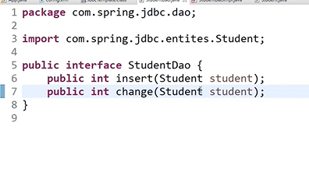
Then will add implementation to override this method too
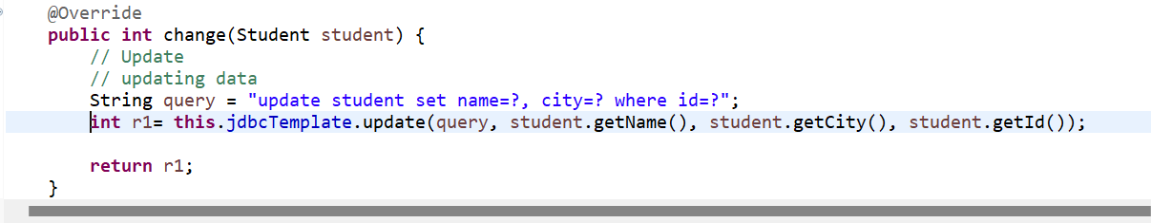
Update.java
package com.spring.jdbc;

import org.springframework.context.ApplicationContext;
import org.springframework.context.support.ClassPathXmlApplicationContext;
import org.springframework.context.ApplicationContext;
import org.springframework.context.support.ClassPathXmlApplicationContext;
import org.springframework.jdbc.core.JdbcTemplate;
import com.spring.jdbc.dao.StudentDao;
import com.spring.jdbc.entities.Student;

public class Update {

public static void main(String[] args) {
// TODO Auto-generated method stub
System.out.println("My Program started........");
System.out.println("=======================================================================");
// Spring JDBC => JdbcTemplate
ApplicationContext context = new ClassPathXmlApplicationContext("com/spring/jdbc/config.xml");

StudentDao studentDao = context.getBean("StudentDao", StudentDao.class);
Student student = new Student();
student.setId(18);
student.setName("Light");
student.setCity("Thane Maharashtra");
int result = studentDao.change(student);
System.out.println("data changed " + result );
System.out.println("=======================================================================");
System.out.println(student);

}

}

Student Entity java remains same obviously

And int implementation class this method gets override
@Override
public int change(Student student) {
// Update
// updating data
String query = "update student set name=?, city=? where id=?";
int r1= this.jdbcTemplate.update(query, student.getName(), student.getCity(), student.getId());

return r1;
}

Now will see deletion part

Delete Operation Using Spring JDBC
Spring JDBC provides easy integration with the database to perform delete operations using either XML-based configuration or annotations. Here's an explanation with examples for both single delete operations and batch delete operations.

Single Delete Operation

XML-Based Configuration
- Steps:
  - Define the JdbcTemplate bean in the XML configuration file.
  - Use JdbcTemplate.update() to execute the delete query.
- Code Example:
jdbc-config.xml:
xml
Copy code
<beans xmlns="http://www.springframework.org/schema/beans"
xmlns:xsi="http://www.w3.org/2001/XMLSchema-instance"
xmlns:context="http://www.springframework.org/schema/context"
xsi:schemaLocation="http://www.springframework.org/schema/beans
http://www.springframework.org/schema/beans/spring-beans.xsd
http://www.springframework.org/schema/context
http://www.springframework.org/schema/context/spring-context.xsd">

<context:component-scan base-package="com.spring.jdbc" />

<!-- DataSource Configuration -->
<bean id="dataSource" class="org.springframework.jdbc.datasource.DriverManagerDataSource">
<property name="driverClassName" value="org.postgresql.Driver" />
<property name="url" value="jdbc:postgresql://localhost:5432/spring" />
<property name="username" value="postgres" />
<property name="password" value="password" />
</bean>

<!-- JdbcTemplate Bean -->
<bean id="jdbcTemplate" class="org.springframework.jdbc.core.JdbcTemplate">
<property name="dataSource" ref="dataSource" />
</bean>

<!-- StudentDao Bean -->
<bean id="studentDao" class="com.spring.jdbc.dao.StudentDaoImpl">
<property name="jdbcTemplate" ref="jdbcTemplate" />
</bean>
</beans>
StudentDao Interface:
java
Copy code
public interface StudentDao {
int delete(int id); // For single delete
}
StudentDaoImpl Implementation:
java
Copy code
public class StudentDaoImpl implements StudentDao {
private JdbcTemplate jdbcTemplate;

public void setJdbcTemplate(JdbcTemplate jdbcTemplate) {
this.jdbcTemplate = jdbcTemplate;
}

@Override
public int delete(int id) {
String query = "DELETE FROM student WHERE id = ?";
return jdbcTemplate.update(query, id);
}
}
Main Class:
java
Copy code
public class MainApp {
public static void main(String[] args) {
ApplicationContext context = new ClassPathXmlApplicationContext("com/spring/jdbc/jdbc-config.xml");
StudentDao studentDao = context.getBean("studentDao", StudentDao.class);

// Single delete operation
int result = studentDao.delete(666);
System.out.println("Number of records deleted: " + result);
}
}

Annotation-Based Configuration
- Steps:
  - Use @Repository for the DAO class.
  - Autowire JdbcTemplate using @Autowired.
- Code Example:
DAO Class:
java
Copy code
@Repository
public class StudentDaoImpl implements StudentDao {

@Autowired
private JdbcTemplate jdbcTemplate;

@Override
public int delete(int id) {
String query = "DELETE FROM student WHERE id = ?";
return jdbcTemplate.update(query, id);
}
}
Main Class:
java
Copy code
@ComponentScan(basePackages = "com.spring.jdbc")
@Configuration
public class AppConfig {}

public class MainApp {
public static void main(String[] args) {
ApplicationContext context = new AnnotationConfigApplicationContext(AppConfig.class);
StudentDao studentDao = context.getBean(StudentDao.class);

// Single delete operation
int result = studentDao.delete(666);
System.out.println("Number of records deleted: " + result);
}
}

Batch Delete Operation

XML-Based Configuration
- Steps:
  - Use JdbcTemplate.batchUpdate() for batch operations.
  - Pass a List of IDs to delete.
- Code Example:
java
Copy code
@Override
public int[] batchDelete(List<Integer> ids) {
String query = "DELETE FROM student WHERE id = ?";
return jdbcTemplate.batchUpdate(query, new BatchPreparedStatementSetter() {
@Override
public void setValues(PreparedStatement ps, int i) throws SQLException {
ps.setInt(1, ids.get(i));
}

@Override
public int getBatchSize() {
return ids.size();
}
});
}

Annotation-Based Configuration
- The same implementation for batch operations can be used with annotations, similar to single deletes.
- DAO Interface:
java
Copy code
public interface StudentDao {
int[] batchDelete(List<Integer> ids);
}
- Main Class:
java
Copy code
public class MainApp {
public static void main(String[] args) {
ApplicationContext context = new AnnotationConfigApplicationContext(AppConfig.class);
StudentDao studentDao = context.getBean(StudentDao.class);

// Batch delete operation
List<Integer> ids = Arrays.asList(101, 102, 103);
int[] results = studentDao.batchDelete(ids);
System.out.println("Number of records deleted: " + Arrays.toString(results));
}
}

Why Use Batch Operations?
- Efficiency: Reduces database calls for multiple delete operations.
- Performance: Faster than executing individual delete queries.

Add another method in our interface
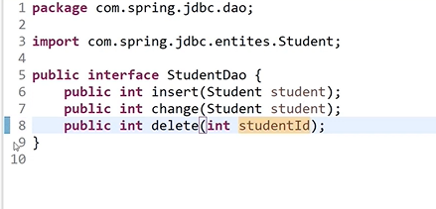
Delete.java will be
package com.spring.jdbc;

import org.springframework.context.ApplicationContext;
import org.springframework.context.support.ClassPathXmlApplicationContext;

import com.spring.jdbc.dao.StudentDao;
import com.spring.jdbc.entities.Student;

public class Delete {

public static void main(String[] args) {
// TODO Auto-generated method stub

System.out.println("My Program started........");
// Spring JDBC => JdbcTemplate
ApplicationContext context = new ClassPathXmlApplicationContext("com/spring/jdbc/config.xml");

StudentDao studentDao = context.getBean("StudentDao", StudentDao.class);

int result = studentDao.delete(55);
System.out.println("Student Deleted " + result );
System.out.println("=======================================================================");

}

}

Student Entity java remains same obviously

Overidden method will be
@Override
public int delete(int id) {
// TODO Auto-generated method stub
String query = "delete from student where id = ?";
int r = this.jdbcTemplate.update(query,id);
return r;
}

Row Mapper Concept | Fetching data using Spring JDBC

Row Mapper Concept in Spring JDBC
In Spring JDBC, a RowMapper is an interface that allows you to map rows of a ResultSet to Java objects. It provides a way to convert the data returned by a query into an object.
The RowMapper is used with JdbcTemplate to retrieve data from the database, typically inside methods like queryForObject() or query().

Key Concepts
- RowMapper Interface:
  - It maps rows of a ResultSet to Java objects.
  - You can implement RowMapper or use an anonymous inner class to map the result set to a Java object.
- Usage in Spring JDBC:
  - When executing a query, you can use JdbcTemplate to fetch the result set and map each row to an object using RowMapper.
- Returning a Collection of Results:
  - When there are multiple rows in the result set, RowMapper helps convert each row into a Java object, which can then be returned as a list of objects.

Example 1: Fetching a Single Record using RowMapper
Let's assume we have a Student class and a table student in the database with columns id, name, and city.

1. Student Class
java
Copy code
package com.spring.jdbc.entities;

public class Student {
private int id;
private String name;
private String city;

// Getters and Setters

public Student() {}

public Student(int id, String name, String city) {
this.id = id;
this.name = name;
this.city = city;
}

@Override
public String toString() {
return "Student [id=" + id + ", name=" + name + ", city=" + city + "]";
}
}

2. RowMapper Implementation
You can create a RowMapper for Student to map the result set.
java
Copy code
package com.spring.jdbc.dao;

import java.sql.ResultSet;
import java.sql.SQLException;
import org.springframework.jdbc.core.RowMapper;
import com.spring.jdbc.entities.Student;

public class StudentRowMapper implements RowMapper<Student> {
@Override
public Student mapRow(ResultSet rs, int rowNum) throws SQLException {
Student student = new Student();
student.setId(rs.getInt("id"));
student.setName(rs.getString("name"));
student.setCity(rs.getString("city"));
return student;
}
}

3. Using JdbcTemplate to Fetch Data
Now, in your DAO class, you can use the RowMapper to map the result set to a Student object.
java
Copy code
package com.spring.jdbc.dao;

import org.springframework.jdbc.core.JdbcTemplate;
import org.springframework.jdbc.core.RowMapper;
import com.spring.jdbc.entities.Student;

public class StudentDao {
private JdbcTemplate jdbcTemplate;

public void setJdbcTemplate(JdbcTemplate jdbcTemplate) {
this.jdbcTemplate = jdbcTemplate;
}

public Student getStudentById(int id) {
String query = "SELECT * FROM student WHERE id = ?";
return jdbcTemplate.queryForObject(query, new Object[]{id}, new StudentRowMapper());
}
}

4. Main Class to Fetch Data
Finally, in your main class, you can fetch and print the details of the student.
java
Copy code
package com.spring.jdbc;

import org.springframework.context.ApplicationContext;
import org.springframework.context.support.ClassPathXmlApplicationContext;
import com.spring.jdbc.dao.StudentDao;
import com.spring.jdbc.entities.Student;

public class Main {
public static void main(String[] args) {
ApplicationContext context = new ClassPathXmlApplicationContext("com/spring/jdbc/config.xml");

StudentDao studentDao = context.getBean("StudentDao", StudentDao.class);

// Fetch student by ID
Student student = studentDao.getStudentById(1);
System.out.println(student); // Will print the details of the student

}
}

Example 2: Fetching Multiple Records using RowMapper
If you want to fetch multiple records from the database, you can use the query() method of JdbcTemplate, which returns a list of results.
java
Copy code
public List<Student> getAllStudents() {
String query = "SELECT * FROM student";
return jdbcTemplate.query(query, new StudentRowMapper());
}
Here, the query() method will execute the SQL and pass each row of the result set to the StudentRowMapper to convert it into a Student object. The resulting list of students will be returned.

Advantages of Using RowMapper
- Decouples Data Access from Application Logic: The RowMapper allows you to separate the database logic (e.g., JDBC handling) from your business logic, making the code more modular.
- Reusability: Once a RowMapper is created, it can be reused across various parts of the application for mapping similar result sets.
- Type Safety: RowMapper ensures that the correct type of object is returned, which minimizes runtime errors.

Using Anonymous Classes for RowMapper
You can also use an anonymous inner class for RowMapper instead of creating a separate class.
java
Copy code
public Student getStudentById(int id) {
String query = "SELECT * FROM student WHERE id = ?";
return jdbcTemplate.queryForObject(query, new Object[]{id}, new RowMapper<Student>() {
@Override
public Student mapRow(ResultSet rs, int rowNum) throws SQLException {
Student student = new Student();
student.setId(rs.getInt("id"));
student.setName(rs.getString("name"));
student.setCity(rs.getString("city"));
return student;
}
});
}

Conclusion
- The RowMapper interface is essential for mapping the result of a query to Java objects.
- By implementing the RowMapper, you can easily convert SQL query results into meaningful Java objects, which helps in abstracting the database layer from the business logic.
- It’s commonly used in queryForObject(), query() methods of JdbcTemplate to handle both single and multiple records.
4o mini

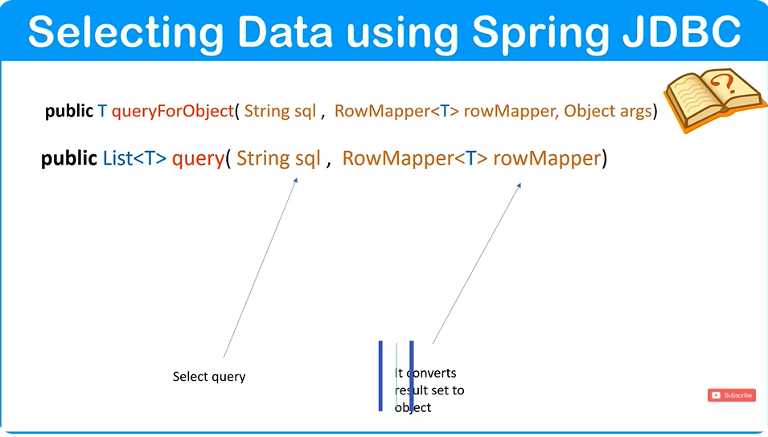
T for object
1st one for single row
2nd for multiple row
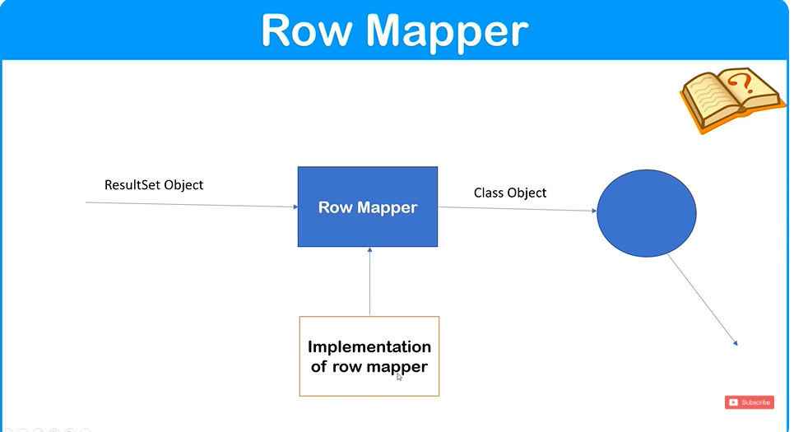
Add another method in our interface
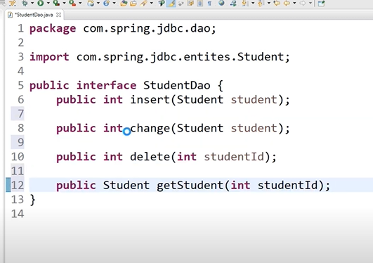
Now we will override this

RowMapper is an interface so we have to implement it
SingleSelect.java
package com.spring.jdbc;
import org.springframework.context.ApplicationContext;
import org.springframework.context.support.ClassPathXmlApplicationContext;
import org.springframework.jdbc.core.JdbcTemplate;

import com.spring.jdbc.dao.StudentDao;
import com.spring.jdbc.entities.Student;

public class SingleSelect {

public static void main(String[] args) {
// TODO Auto-generated method stub

System.out.println("My Program started........");
System.out.println("=======================================================================");

// Spring JDBC => JdbcTemplate
ApplicationContext context = new ClassPathXmlApplicationContext("com/spring/jdbc/config.xml");

StudentDao studentDao = context.getBean("StudentDao", StudentDao.class);
Student stud = studentDao.getstudent(118);

System.out.println(stud);
System.out.println("=======================================================================");

}
}

RowmapperImp that we are implementing is
package com.spring.jdbc.dao;

import java.sql.ResultSet;
import java.sql.SQLException;

import org.springframework.jdbc.core.RowMapper;

import com.spring.jdbc.entities.Student;

public class RowMapperImpl implements RowMapper<Student> {

@Override
public Student mapRow(ResultSet rs, int rowNum) throws SQLException {
// TODO Auto-generated method stub
Student student = new Student();
student.setId(rs.getInt(1));
student.setName(rs.getString(2));
student.setCity(rs.getString(3));
return student;
}

}

And now the override method as usual
@Override
public Student getstudent(int id) {
// TODO Auto-generated method stub
//Selecting single Student data
String query= "select * from student where id=?";
RowMapper<Student> rowMapper=new RowMapperImpl();
Student student = this.jdbcTemplate.queryForObject(query, rowMapper,id);

return student;
}

Now will do Selecting Multiple Objects using Spring Jdbc
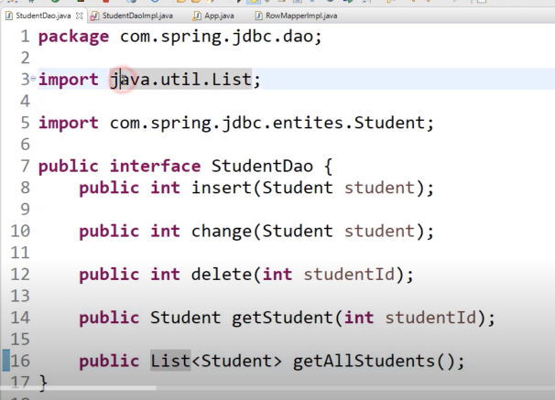
Add method to override and implement as usual in our Interface as usual
MultipleSelect.java
package com.spring.jdbc;
import java.util.List;

import org.springframework.context.ApplicationContext;
import org.springframework.context.support.ClassPathXmlApplicationContext;
import org.springframework.jdbc.core.JdbcTemplate;

import com.spring.jdbc.dao.StudentDao;
import com.spring.jdbc.entities.Student;

public class MultipleSelect {

public static void main(String[] args) {
// TODO Auto-generated method stub

System.out.println("My Program started........");
System.out.println("=======================================================================");

// Spring JDBC => JdbcTemplate
ApplicationContext context = new ClassPathXmlApplicationContext("com/spring/jdbc/config.xml");

StudentDao studentDao = context.getBean("StudentDao", StudentDao.class);
List<Student> student=studentDao.getallstudent();
for(Student s : student)
{
System.out.println(s);
System.out.println("_________________________________________________________________________");
}
System.out.println("=======================================================================");

}
}

Overridden Method
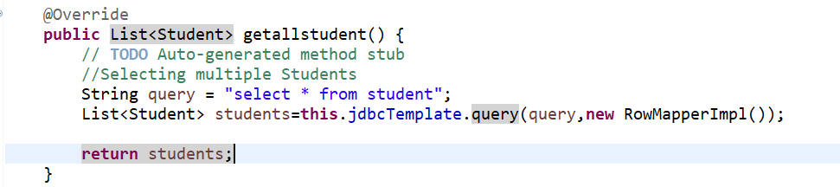

Rest all remains same

Configuring Spring JDBC without XML involves using Java-based configuration with the help of @Configuration, @Bean, and related annotations. Below is an example of how to configure Spring JDBC without XML:

Steps to Configure Spring JDBC without XML
- Add Dependencies:
Ensure your pom.xml (for Maven) or build.gradle (for Gradle) includes the necessary Spring JDBC and database driver dependencies.
xml
Copy code
<!-- Maven Dependency -->
<dependency>
<groupId>org.springframework</groupId>
<artifactId>spring-jdbc</artifactId>
<version>5.3.30</version>
</dependency>
<dependency>
<groupId>org.postgresql</groupId>
<artifactId>postgresql</artifactId>
<version>42.6.0</version>
</dependency>
- Java Configuration:
Create a configuration class annotated with @Configuration to define beans.
java
Copy code
import org.springframework.context.annotation.Bean;
import org.springframework.context.annotation.Configuration;
import org.springframework.jdbc.core.JdbcTemplate;
import org.springframework.jdbc.datasource.DriverManagerDataSource;

import javax.sql.DataSource;

@Configuration
public class SpringJdbcConfig {

@Bean
public DataSource dataSource() {
DriverManagerDataSource dataSource = new DriverManagerDataSource();
dataSource.setDriverClassName("org.postgresql.Driver");
dataSource.setUrl("jdbc:postgresql://localhost:5432/spring");
dataSource.setUsername("postgres");
dataSource.setPassword("password");
return dataSource;
}

@Bean
public JdbcTemplate jdbcTemplate(DataSource dataSource) {
return new JdbcTemplate(dataSource);
}
}
- DAO Layer:
Create a DAO class to interact with the database.
java
Copy code
import org.springframework.jdbc.core.JdbcTemplate;

public class StudentDao {
private JdbcTemplate jdbcTemplate;

public StudentDao(JdbcTemplate jdbcTemplate) {
this.jdbcTemplate = jdbcTemplate;
}

// Insert operation
public int insertStudent(int id, String name, String city) {
String query = "INSERT INTO student (id, name, city) VALUES (?, ?, ?)";
return jdbcTemplate.update(query, id, name, city);
}

// Fetch operation
public String getStudentNameById(int id) {
String query = "SELECT name FROM student WHERE id = ?";
return jdbcTemplate.queryForObject(query, new Object[]{id}, String.class);
}
}
- Main Application:
Use the configuration and DAO in the main application.
java
Copy code
import org.springframework.context.ApplicationContext;
import org.springframework.context.annotation.AnnotationConfigApplicationContext;

public class MainApp {
public static void main(String[] args) {
ApplicationContext context = new AnnotationConfigApplicationContext(SpringJdbcConfig.class);

StudentDao studentDao = new StudentDao(context.getBean(JdbcTemplate.class));

// Insert a student
int result = studentDao.insertStudent(1, "Yash", "Thane");
System.out.println("Rows inserted: " + result);

// Fetch a student's name by ID
String studentName = studentDao.getStudentNameById(1);
System.out.println("Student Name: " + studentName);
}
}
- Database Table:
Ensure the table exists in your database.
sql
Copy code
CREATE TABLE student (
id INT PRIMARY KEY,
name VARCHAR(100),
city VARCHAR(50)
);

Advantages of Java-based Configuration
- Type-Safety: Errors are caught at compile-time, unlike XML-based configuration.
- Easier Refactoring: Code-based configurations are easier to refactor.
- No Separate Files: Everything is managed in Java classes, reducing dependency on XML files.
This configuration approach is modern and aligns with Spring Boot practices, making it highly recommended for new projects.
4o

Jdbcconfig.java
package com.spring.jdbc;
import org.springframework.context.ApplicationContext;
import org.springframework.context.support.ClassPathXmlApplicationContext;
import org.springframework.jdbc.core.JdbcTemplate;

import com.spring.jdbc.dao.StudentDao;
import com.spring.jdbc.entities.Student;

public class SingleSelect {

public static void main(String[] args) {
// TODO Auto-generated method stub

System.out.println("My Program started........");
System.out.println("=======================================================================");

// Spring JDBC => JdbcTemplate
ApplicationContext context = new ClassPathXmlApplicationContext("com/spring/jdbc/config.xml");

StudentDao studentDao = context.getBean("StudentDao", StudentDao.class);
Student stud = studentDao.getstudent(118);

System.out.println(stud);
System.out.println("=======================================================================");

}
}

App.java
package com.spring.jdbc;

import org.springframework.context.ApplicationContext;
import org.springframework.context.annotation.AnnotationConfigApplicationContext;

import com.spring.jdbc.dao.StudentDao;
import com.spring.jdbc.entities.Student;

public class AnnoApp {

public static void main(String[] args) {
// TODO Auto-generated method stub
System.out.println("My Program started........");
System.out.println("=======================================================================");

ApplicationContext context = new AnnotationConfigApplicationContext(JdbcConfig.class);
StudentDao studentDao = context.getBean("studentDao", StudentDao.class);
Student stud = studentDao.getstudent(118);

System.out.println(stud);
System.out.println("=======================================================================");

Student student = new Student();
student.setId(10);
student.setName("Sachin tendulkar");
student.setCity("Mumbai");

int result = studentDao.insert(student);

System.out.println("Student added " + result );
System.out.println("=======================================================================");
System.out.println(student);

}

}

Rest all same
Spring ORM Tutorial | Introduction to Spring ORM | Why Spring ORM | Full Game of Spring ORM | Hindi

Spring ORM (Object-Relational Mapping) is a framework that simplifies the integration of ORM tools like Hibernate, JPA, and JDO with Spring applications. It provides a layer of abstraction for ORM frameworks, making it easier to manage database interactions, transactions, and resource handling within a Spring context.

Key Features of Spring ORM:
- Simplified Integration:
  - Works with ORM tools like Hibernate, JPA, and JDO.
  - Provides support classes for these ORM frameworks.
- Transaction Management:
  - Integrates with Spring's declarative transaction management.
  - Allows consistent transaction handling across ORM frameworks.
- HibernateTemplate/JpaTemplate:
  - Simplifies common tasks like saving, updating, deleting, and querying entities.
  - Abstracts repetitive boilerplate code.
- DAO Support:
  - Provides @Repository annotation for DAO classes.
  - Offers exception translation into Spring-specific exceptions.

Steps to Configure Spring ORM:

1. Add Dependencies:
Include the necessary Spring ORM, Hibernate/JPA dependencies in your pom.xml (if using Maven):
xml
Copy code
<dependency>
<groupId>org.springframework</groupId>
<artifactId>spring-orm</artifactId>
<version>5.3.12</version>
</dependency>
<dependency>
<groupId>org.hibernate</groupId>
<artifactId>hibernate-core</artifactId>
<version>5.6.2.Final</version>
</dependency>
<dependency>
<groupId>javax.persistence</groupId>
<artifactId>javax.persistence-api</artifactId>
<version>2.2</version>
</dependency>

2. Configuration Without XML:
Create a configuration class using Spring Java-based configuration.

a. DataSource Bean:
java
Copy code
@Bean
public DataSource getDataSource() {
DriverManagerDataSource dataSource = new DriverManagerDataSource();
dataSource.setDriverClassName("com.mysql.cj.jdbc.Driver");
dataSource.setUrl("jdbc:mysql://localhost:3306/your_database");
dataSource.setUsername("your_username");
dataSource.setPassword("your_password");
return dataSource;
}

b. Hibernate SessionFactory:
java
Copy code
@Bean
public LocalSessionFactoryBean getSessionFactory() {
LocalSessionFactoryBean sessionFactory = new LocalSessionFactoryBean();
sessionFactory.setDataSource(getDataSource());
sessionFactory.setPackagesToScan("com.example.entities");
Properties hibernateProperties = new Properties();
hibernateProperties.put("hibernate.dialect", "org.hibernate.dialect.MySQLDialect");
hibernateProperties.put("hibernate.show_sql", "true");
sessionFactory.setHibernateProperties(hibernateProperties);
return sessionFactory;
}

c. Transaction Manager:
java
Copy code
@Bean
public HibernateTransactionManager getTransactionManager() {
HibernateTransactionManager transactionManager = new HibernateTransactionManager();
transactionManager.setSessionFactory(getSessionFactory().getObject());
return transactionManager;
}

3. DAO Implementation:

a. Entity Class (e.g., Student):
java
Copy code
@Entity
@Table(name = "students")
public class Student {
@Id
@GeneratedValue(strategy = GenerationType.IDENTITY)
private int id;

@Column(name = "name")
private String name;

@Column(name = "city")
private String city;

// Getters and Setters
}

b. DAO Interface:
java
Copy code
public interface StudentDao {
int saveStudent(Student student);
Student getStudentById(int id);
}

c. DAO Implementation:
java
Copy code
@Repository
public class StudentDaoImpl implements StudentDao {

@Autowired
private SessionFactory sessionFactory;

@Override
public int saveStudent(Student student) {
Session session = sessionFactory.getCurrentSession();
return (int) session.save(student);
}

@Override
public Student getStudentById(int id) {
Session session = sessionFactory.getCurrentSession();
return session.get(Student.class, id);
}
}

4. Enable Transaction Management:
Add @EnableTransactionManagement to your configuration class:
java
Copy code
@Configuration
@EnableTransactionManagement
@ComponentScan(basePackages = "com.example")
public class AppConfig {
// Beans defined here
}

5. Main Application:
java
Copy code
public class MainApp {
public static void main(String[] args) {
ApplicationContext context = new AnnotationConfigApplicationContext(AppConfig.class);
StudentDao studentDao = context.getBean(StudentDao.class);

Student student = new Student();
student.setName("John");
student.setCity("New York");

int id = studentDao.saveStudent(student);
System.out.println("Student saved with ID: " + id);

Student fetchedStudent = studentDao.getStudentById(id);
System.out.println("Fetched Student: " + fetchedStudent);
}
}

Summary:
Spring ORM simplifies ORM tool integration, allowing developers to focus on business logic. It works well with Hibernate and JPA, provides transaction management, and reduces boilerplate code for DAO implementations. Use annotations or XML for configuration as per your project's requirements.
4o

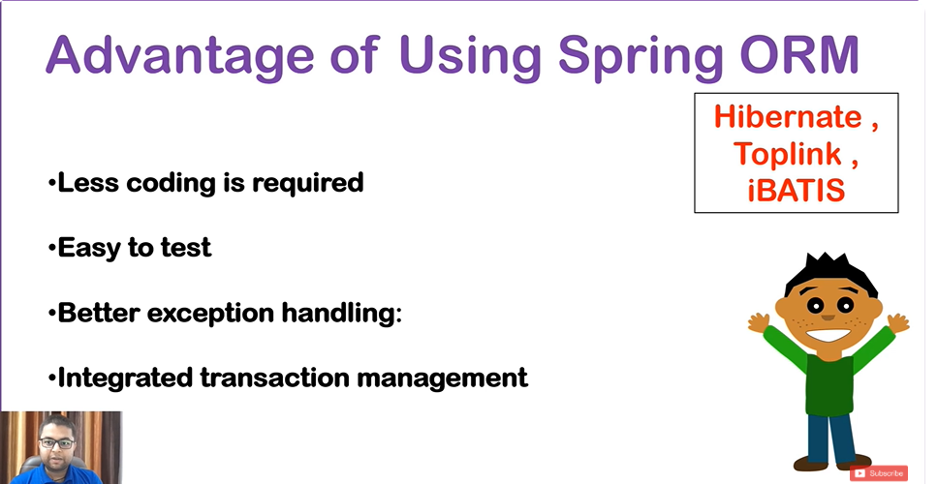
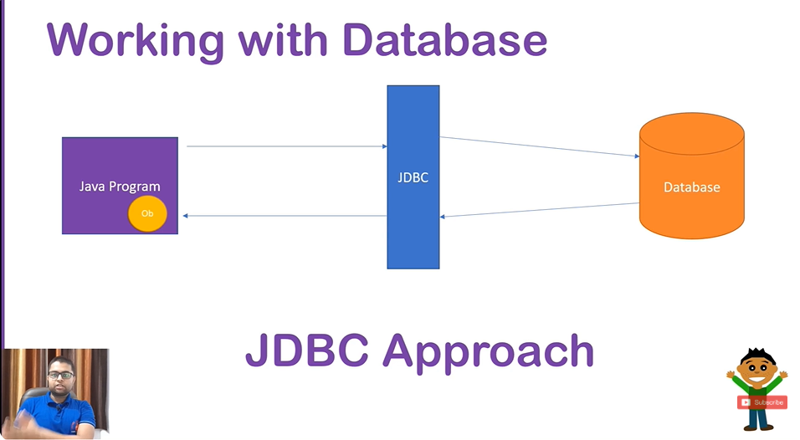
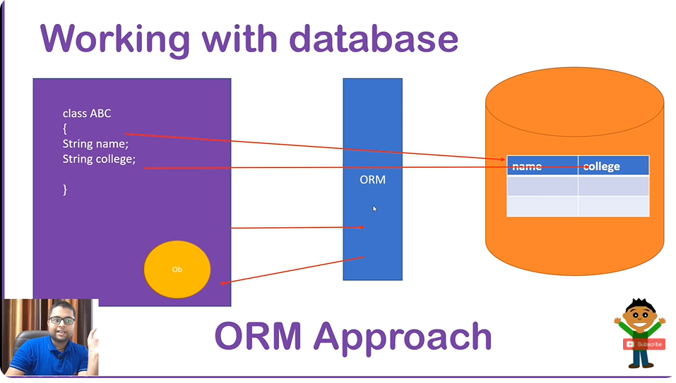
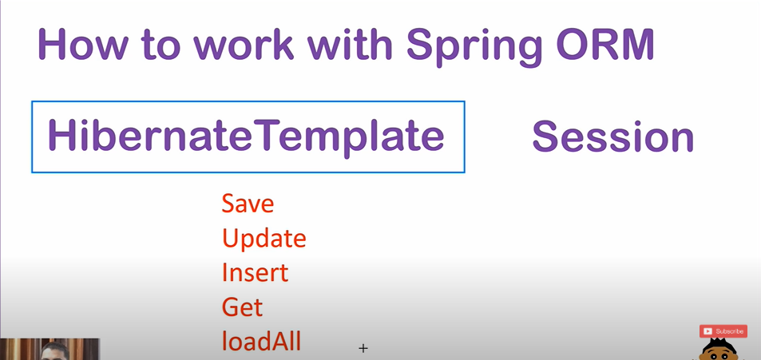

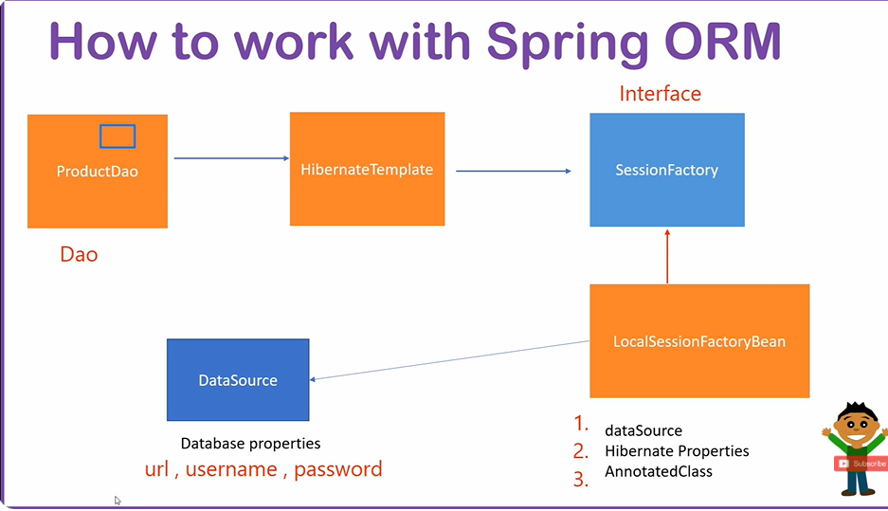

Remember The diagram flow its too IMP
Config.xml
<?xml version="1.0" encoding="UTF-8"?>
<beans xmlns="http://www.springframework.org/schema/beans"
xmlns:xsi="http://www.w3.org/2001/XMLSchema-instance"
xmlns:context="http://www.springframework.org/schema/context"
xmlns:p="http://www.springframework.org/schema/p"
xmlns:tx="http://www.springframework.org/schema/tx"
xsi:schemaLocation="http://www.springframework.org/schema/beans
http://www.springframework.org/schema/beans/spring-beans.xsd
http://www.springframework.org/schema/context
http://www.springframework.org/schema/context/spring-context.xsd
http://www.springframework.org/schema/tx
http://www.springframework.org/schema/tx/spring-tx.xsd

">

<tx:annotation-driven></tx:annotation-driven>

<!--StudentDao entity bean Declaration-->
<bean class="com.spring.orm.dao.StudentDao" name="StudentDao">
<property name="hibernateTemplate" ref="hiber"></property></bean>

<!--HibernateTemplate bean Declaration-->
<bean class="org.springframework.orm.hibernate5.HibernateTemplate" name="hiber">

<property name="sessionFactory" ref="localbeanfactory"></property>
</bean>
<!--LocalSessionfactory bean Declaration-->
<bean class="org.springframework.orm.hibernate5.LocalSessionFactoryBean" name="localbeanfactory">

<property name="dataSource" ref="ds"></property>
<property name="hibernateProperties" >
<props>
<prop key="hibernate.dialect">org.hibernate.dialect.PostgreSQLDialect</prop>
<prop key="hibernate.show_sql">true</prop>
<prop key="hibernate.hbm2ddl.auto">update</prop>

</props>

</property>
<property name="annotatedClasses">
<list>
<value>com.spring.orm.entities.Student</value>
</list></property>

</bean>
<!--Datasource bean Declaration-->
<bean class="org.springframework.jdbc.datasource.DriverManagerDataSource" name="ds">
<property name="driverClassName" value="org.postgresql.Driver"></property>
<property name="url" value="jdbc:postgresql://localhost:5432/spring"></property>
<property name="username" value="postgres"></property>
<property name="password" value="light"></property>

</bean>
<bean class="org.springframework.orm.hibernate5.HibernateTransactionManager" name="transactionManager">
<property name="sessionFactory" ref="localbeanfactory"/>
</bean>

</beans>
We have to declare bean and ref for everyclass we using

Student.java
package com.spring.orm.entities;

import javax.persistence.Entity;
import javax.persistence.Id;
import javax.persistence.Table;

@Entity
@Table(name = "Student_SpringORM")
public class Student {
@Id
private int id;
private String name;
private String city;
public int getId() {
return id;
}
public void setId(int id) {
this.id = id;
}
public String getName() {
return name;
}
public void setName(String name) {
this.name = name;
}
public String getCity() {
return city;
}
public void setCity(String city) {
this.city = city;
}
public Student(int id, String name, String city) {
super();
this.id = id;
this.name = name;
this.city = city;
}
public Student() {
super();
// TODO Auto-generated constructor stub
}
@Override
public String toString() {
return "Student [id=" + id + ", name=" + name + ", city=" + city + "]";
}

}

StudentDao.java
package com.spring.orm.dao;

import org.springframework.orm.hibernate5.HibernateTemplate;
import org.springframework.transaction.annotation.Transactional;

import com.spring.orm.entities.Student;
@Transactional
public class StudentDao {

private HibernateTemplate hibernateTemplate;

public int insert(Student student)

{
Integer i = (Integer)this.hibernateTemplate.save(student);
return i;
}

public HibernateTemplate getHibernateTemplate() {
return hibernateTemplate;
}

public void setHibernateTemplate(HibernateTemplate hibernateTemplate) {
this.hibernateTemplate = hibernateTemplate;
}

public StudentDao(HibernateTemplate hibernateTemplate) {
super();
this.hibernateTemplate = hibernateTemplate;
}

@Override
public String toString() {
return "StudentDao [hibernateTemplate=" + hibernateTemplate + "]";
}

public StudentDao() {
super();
// TODO Auto-generated constructor stub
}

}

App.java
package com.spring.orm;

import org.springframework.context.ApplicationContext;
import org.springframework.context.support.ClassPathXmlApplicationContext;

import com.spring.orm.dao.StudentDao;
import com.spring.orm.entities.Student;

/**
* Hello world!
*
*/
public class App
{
public static void main( String[] args )
{
ApplicationContext context=new ClassPathXmlApplicationContext("config.xml");
StudentDao studentdao=context.getBean("StudentDao", StudentDao.class);
Student student = new Student(18,"virat kohli","Bangloree");
int r = studentdao.insert(student);
System.out.println("done " + r);

System.out.println(student);
System.out.println("_________________________________________________________________________________________________");

Student student1 = new Student(45,"Rohit Sharma","Mumbai");
int r1 = studentdao.insert(student1);
System.out.println("done " + r1);
System.out.println(student1);
System.out.println("_________________________________________________________________________________________________");

Student student2 = new Student(01,"KL Rahul","Delhi");
System.out.println(student2);
int r2 = studentdao.insert(student2);
System.out.println("done " + r2);
System.out.println("_________________________________________________________________________________________________");

}

}

CRUD USING SPRING ORM
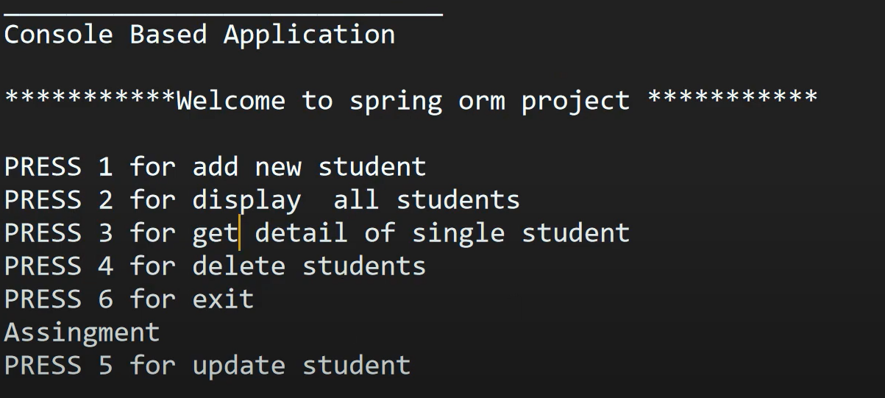

Introduction to Spring MVC | Why Spring MVC | Spring MVC Tutorial

Introduction to Spring MVC
Spring MVC is a module of the Spring Framework used to build web applications following the Model-View-Controller (MVC) design pattern. It simplifies the development of flexible and loosely coupled web applications. It is widely used for creating web applications in Java due to its robustness, flexibility, and ease of integration.

Why Spring MVC?
- MVC Design Pattern:
Spring MVC is built on the Model-View-Controller design pattern, which separates business logic (Model), user interface (View), and request handling (Controller).
- Flexible and Scalable:
Spring MVC supports large-scale enterprise applications while providing flexibility to developers.
- Ease of Integration:
Spring MVC integrates seamlessly with other Spring components like Spring Boot, Spring Data, and Hibernate.
- Annotation-Based Configuration:
Modern Spring MVC applications use annotations (@Controller, @RequestMapping) to reduce boilerplate code, making the application cleaner and easier to manage.
- Loose Coupling:
Components in Spring MVC are loosely coupled, meaning changes in one layer don't heavily impact others.
- RESTful Support:
Spring MVC makes it easy to create RESTful APIs with annotations like @RestController.
- Built-In Features:
Spring MVC provides features like form handling, validation, exception handling, internationalization (i18n), and more.

Key Concepts of Spring MVC
- Model: Represents the application data or business logic. It usually involves POJOs (Plain Old Java Objects).
- View: Handles the presentation layer. Technologies like JSP, Thymeleaf, or FreeMarker are used for views.
- Controller: Processes user requests and returns responses. Controllers are annotated with @Controller and @RequestMapping.

Spring MVC Workflow
The Spring MVC request-processing workflow involves the following steps:
- Client Request: The client sends a request to the server.
- DispatcherServlet: This is the front controller in Spring MVC. It receives the incoming request.
- Handler Mapping: DispatcherServlet uses Handler Mapping to find the appropriate controller for the request.
- Controller: The controller processes the request, interacts with the Model (business logic), and prepares the response.
- View Resolver: Based on the controller’s response, the View Resolver identifies the appropriate view.
- View: The chosen view generates the HTML response using the model data.
- Response: The response is sent back to the client.

Spring MVC Tutorial
Here is a simple example of a Spring MVC setup:

1. Add Dependencies
For Maven projects, include the Spring MVC dependency in your pom.xml:
xml
Copy code
<dependency>
<groupId>org.springframework</groupId>
<artifactId>spring-webmvc</artifactId>
<version>5.3.8</version>
</dependency>

2. DispatcherServlet Configuration
Create web.xml to configure the DispatcherServlet:
xml
Copy code
<web-app>
<servlet>
<servlet-name>dispatcher</servlet-name>
<servlet-class>org.springframework.web.servlet.DispatcherServlet</servlet-class>
<load-on-startup>1</load-on-startup>
</servlet>
<servlet-mapping>
<servlet-name>dispatcher</servlet-name>
<url-pattern>/</url-pattern>
</servlet-mapping>
</web-app>

3. Spring Configuration File
Create dispatcher-servlet.xml to define component scanning and view resolver:
xml
Copy code
<context:component-scan base-package="com.example" />
<bean
class="org.springframework.web.servlet.view.InternalResourceViewResolver">
<property name="prefix" value="/WEB-INF/views/" />
<property name="suffix" value=".jsp" />
</bean>

4. Controller Class
Create a controller class using annotations:
java
Copy code
package com.example.controller;

import org.springframework.stereotype.Controller;
import org.springframework.ui.Model;
import org.springframework.web.bind.annotation.RequestMapping;

@Controller
public class HomeController {

@RequestMapping("/home")
public String home(Model model) {
model.addAttribute("message", "Welcome to Spring MVC!");
return "home"; // Refers to home.jsp
}
}

5. Create View (JSP)
Create a JSP file (home.jsp) under /WEB-INF/views/:
html
Copy code
<!DOCTYPE html>
<html>
<head>
<title>Spring MVC</title>
</head>
<body>
<h1>${message}</h1>
</body>
</html>

6. Run the Application
Deploy your application to a servlet container like Tomcat, and access:
bash
Copy code
http://localhost:8080/yourapp/home

Summary
- Spring MVC is a powerful module of Spring for building web applications.
- It follows the Model-View-Controller design pattern.
- It simplifies web development with annotation-based configurations and integrated components.
- Spring MVC can be used to create both web pages and RESTful APIs.

Summary of Alternatives
Framework | Best For | Key Features
Spring WebFlux | Reactive web apps | Non-blocking, Mono/Flux, microservices
Jakarta EE | Standard enterprise projects | JAX-RS, Servlets, robust features
JAX-RS (Jersey) | RESTful APIs | Lightweight, annotations-based
Struts 2 | Legacy projects | MVC, interceptor-based
Vaadin | Rich, component-based UI apps | Java-based UI design
Play Framework | Reactive applications | Non-blocking, Akka integration
Micronaut | Microservices & serverless | Lightweight, fast startup
Quarkus | Kubernetes & cloud-native apps | Native compilation, optimized for cloud
Apache Wicket | Stateful component-based apps | Component-oriented, Java + HTML
JSF | Component-based UIs | Standardized in Jakarta EE

Choosing the Right Alternative
- Use Spring Boot + WebFlux for reactive applications.
- Use JAX-RS (Jersey) for RESTful APIs without Spring.
- Use Micronaut or Quarkus for cloud-native and lightweight microservices.
- Use Vaadin or Apache Wicket for building UI-heavy applications.
- Use Jakarta EE for standardized enterprise-grade solutions.
Each of these frameworks offers unique benefits based on your project needs! 🚀

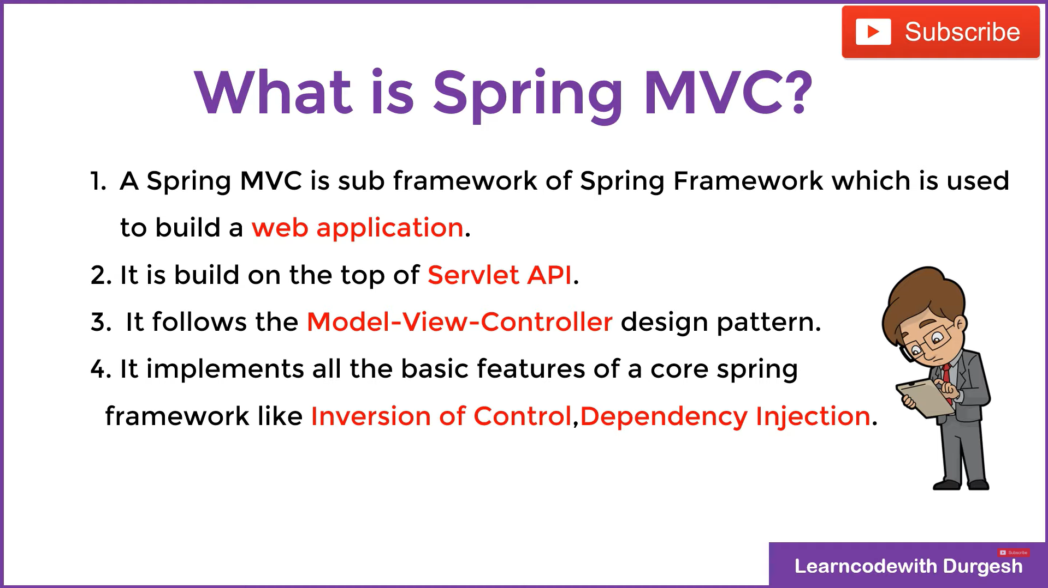
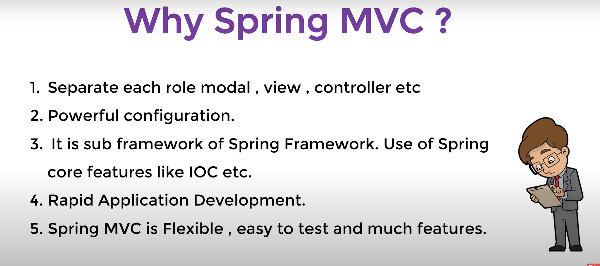
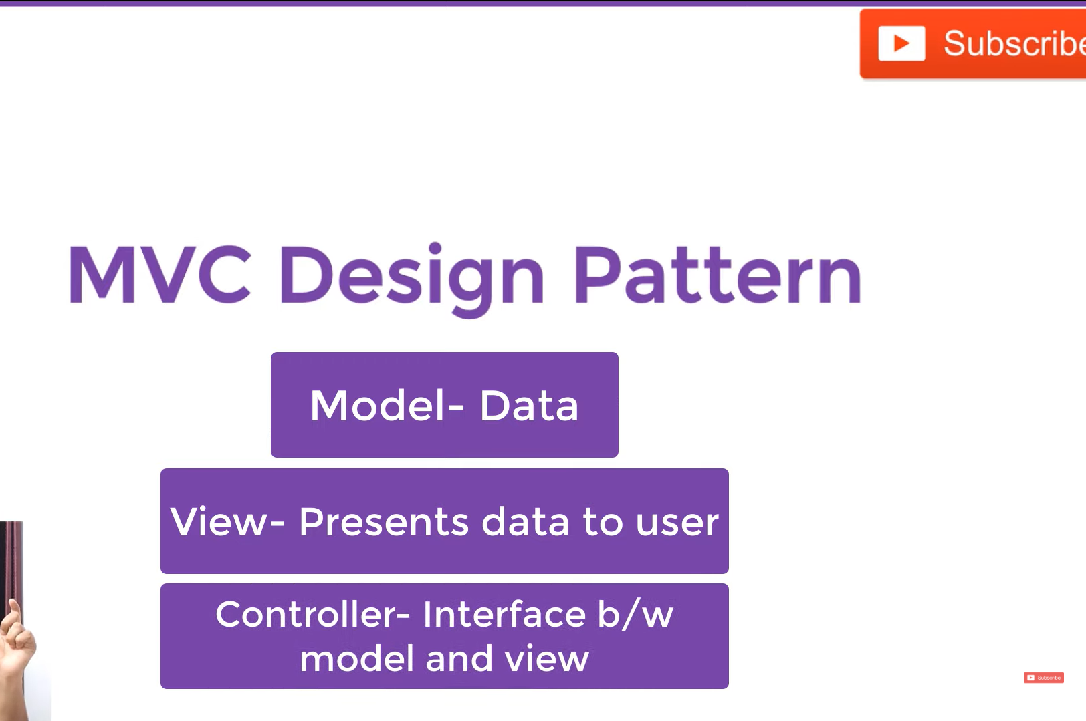

Complete Working of Spring MVC
Spring MVC (Model-View-Controller) is a framework for building web applications in Java. It simplifies the development of web-based applications by following the MVC design pattern. Here's a complete explanation of how Spring MVC works, including setup, flow, and essential components.

Spring MVC Workflow
- User Request: A client (user) makes an HTTP request (e.g., typing a URL or clicking a link).
- Front Controller (DispatcherServlet): The request is intercepted by DispatcherServlet, which is the central controller in Spring MVC.
- Handler Mapping: DispatcherServlet consults the Handler Mapping to find which controller to forward the request to.
- Controller: The appropriate Controller processes the request and prepares the data (Model).
- View Resolver: The View Resolver resolves the logical view name (e.g., "home") and maps it to the actual view (e.g., home.jsp).
- View Rendering: The chosen view (like JSP) renders the response and sends it back to the client.

Spring MVC Components
The key components in Spring MVC include:
- DispatcherServlet (Front Controller)
- Controller (Handles user requests)
- Model (Carries data)
- View (UI for displaying results)
- Handler Mapping (Maps URL to controller)
- View Resolver (Maps view name to actual view file)

Spring MVC Step-by-Step Example
Below is a working Spring MVC example:

1. Add Dependencies (pom.xml for Maven projects)
Add Spring MVC and related dependencies.
xml
Copy code
<dependencies>
<!-- Spring MVC -->
<dependency>
<groupId>org.springframework</groupId>
<artifactId>spring-webmvc</artifactId>
<version>5.3.10</version>
</dependency>

<!-- Servlet API -->
<dependency>
<groupId>javax.servlet</groupId>
<artifactId>javax.servlet-api</artifactId>
<version>4.0.1</version>
<scope>provided</scope>
</dependency>

<!-- JSTL for JSP -->
<dependency>
<groupId>javax.servlet.jsp.jstl</groupId>
<artifactId>jstl</artifactId>
<version>1.2</version>
</dependency>

<!-- Spring Context -->
<dependency>
<groupId>org.springframework</groupId>
<artifactId>spring-context</artifactId>
<version>5.3.10</version>
</dependency>
</dependencies>

2. Configure web.xml
The DispatcherServlet is configured here to handle requests.
xml
Copy code
<web-app>
<servlet>
<servlet-name>dispatcher</servlet-name>
<servlet-class>org.springframework.web.servlet.DispatcherServlet</servlet-class>
<load-on-startup>1</load-on-startup>
</servlet>
<servlet-mapping>
<servlet-name>dispatcher</servlet-name>
<url-pattern>/</url-pattern>
</servlet-mapping>
</web-app>
- DispatcherServlet is mapped to handle all requests ("/").

3. Create dispatcher-servlet.xml (Spring Configuration)
This file contains configuration for Controller, View Resolver, and other beans.
xml
Copy code
<beans xmlns="http://www.springframework.org/schema/beans"
xmlns:xsi="http://www.w3.org/2001/XMLSchema-instance"
xsi:schemaLocation="http://www.springframework.org/schema/beans
http://www.springframework.org/schema/beans/spring-beans.xsd">

<!-- View Resolver -->
<bean id="viewResolver" class="org.springframework.web.servlet.view.InternalResourceViewResolver">
<property name="prefix" value="/WEB-INF/views/" />
<property name="suffix" value=".jsp" />
</bean>
</beans>
- InternalResourceViewResolver: Resolves logical view names to actual JSP files in /WEB-INF/views.

4. Create Controller
Controllers handle user requests. Use the @Controller annotation.
java
Copy code
package com.example.controllers;

import org.springframework.stereotype.Controller;
import org.springframework.ui.Model;
import org.springframework.web.bind.annotation.RequestMapping;

@Controller
public class HomeController {

@RequestMapping("/")
public String home(Model model) {
model.addAttribute("message", "Welcome to Spring MVC!");
return "home"; // Logical view name (home.jsp)
}
}
- @RequestMapping("/"): Maps the root URL to the home() method.
- Model: Used to pass data to the view.
- return "home": Refers to home.jsp.

5. Create JSP View
Place the JSP file in /WEB-INF/views/home.jsp.
home.jsp:
jsp
Copy code
<%@ taglib uri="http://java.sun.com/jsp/jstl/core" prefix="c" %>
<!DOCTYPE html>
<html>
<head>
<title>Spring MVC Example</title>
</head>
<body>
<h1>${message}</h1>
</body>
</html>
- ${message}: Accesses the data added to the Model.

6. Directory Structure
Ensure your project structure looks like this:
css
Copy code
src/main/webapp/
WEB-INF/
views/
home.jsp
web.xml

src/main/java/
com.example.controllers/
HomeController.java

src/main/resources/
dispatcher-servlet.xml

How It Works
- User Request: Access http://localhost:8080/ in a browser.
- DispatcherServlet: Intercepts the request.
- Controller: HomeController processes the request.
- View Resolver: Resolves "home" to /WEB-INF/views/home.jsp.
- Response: The JSP view is rendered and displayed.

Key Annotations in Spring MVC
- @Controller: Marks a class as a Spring MVC controller.
- @RequestMapping: Maps URLs to handler methods.
- @ModelAttribute: Binds form data to a model.
- @RequestParam: Retrieves request parameters.
- @PathVariable: Extracts values from the URL path.

Advantages of Spring MVC
- Separation of Concerns: Clear separation of model, view, and controller.
- Flexible View Technologies: Supports JSP, Thymeleaf, FreeMarker, etc.
- Annotation-Based: Simplifies configuration with annotations.
- Integration: Easily integrates with Spring features like DI, AOP, and Hibernate.

Conclusion
Spring MVC is a robust and flexible framework for building web applications in Java. It provides a clean separation of concerns using the MVC design pattern and allows developers to build scalable, maintainable applications.
This step-by-step tutorial covers all key components of Spring MVC: DispatcherServlet, Controller, View Resolver, Model, and View. 🚀

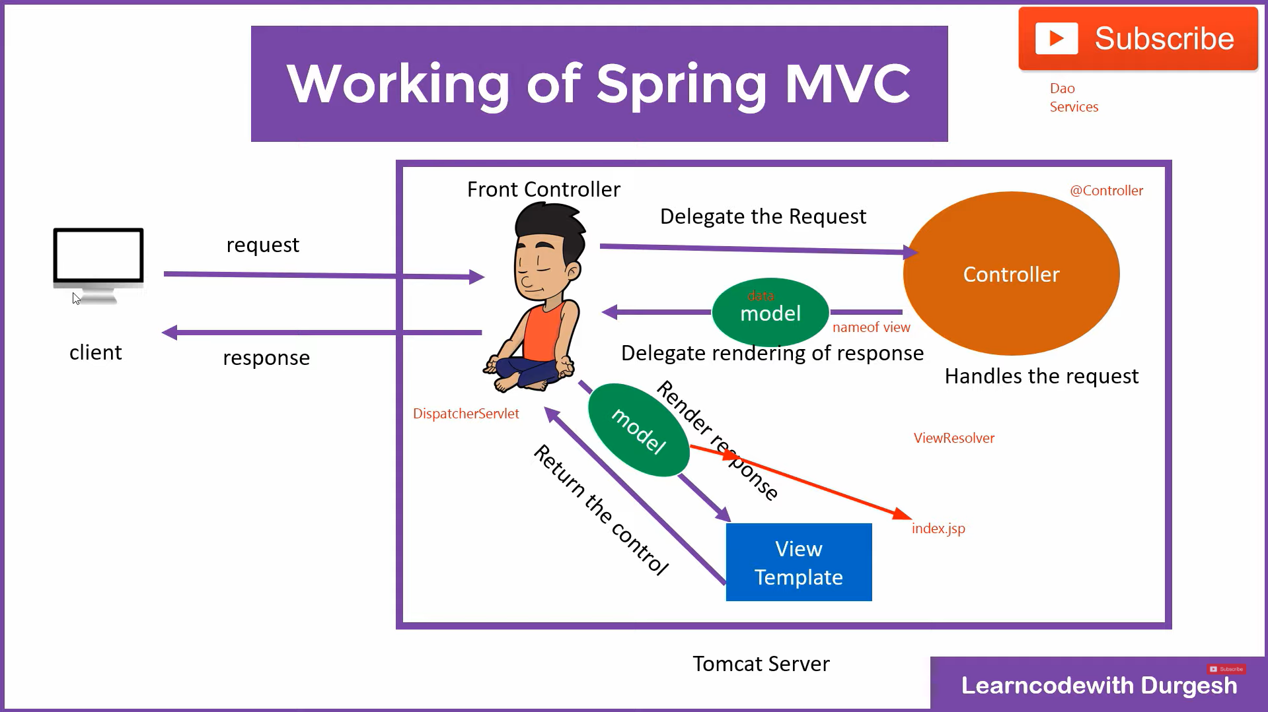

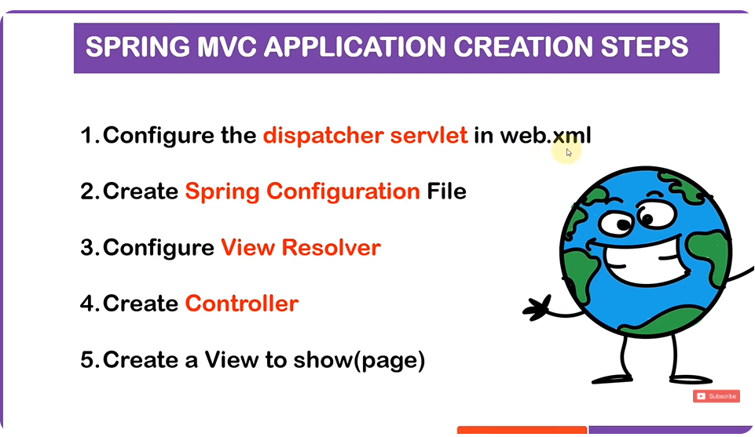

Step 1 Configure Dispatcher Servlet
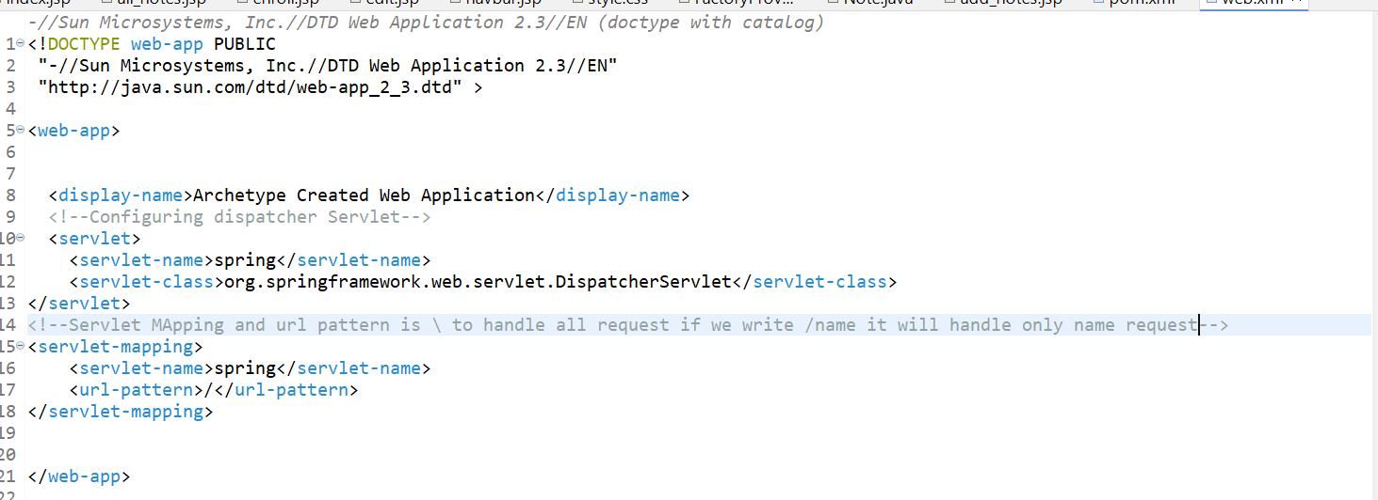

Step 2 Spring Configuration XML(File Name Standards= servlet name- Servlet.xml)
By using this Naming Convention spring will automatically load the xml
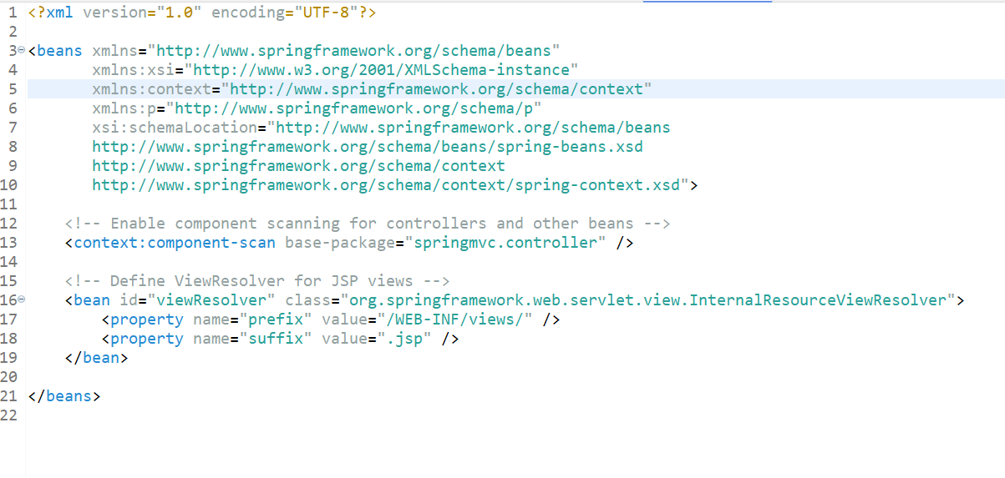
Here we have set the values for our viewresolver using suffix and prefix so the controller can send the pages

Step 3
VIEW RESOLVER IS ALSO A BEAN I.E A CLASS
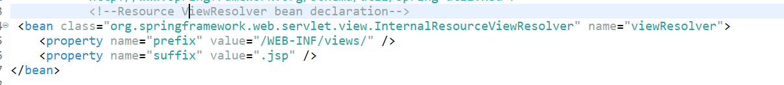

Step 4 create controller
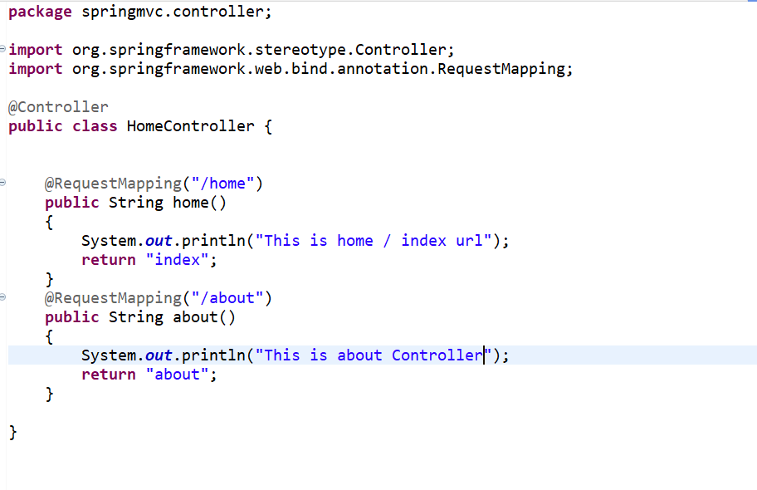
Now just create the pages with name index and about as this are returning values of our controller method
For /home index and suffix prefix from our viewcontrol
THIS SUMS UP THE BASIC MVC

Sending Data From Controller to View | Full Concept Explain | Spring MVC Tutorial

Sending Data From Controller to View in Spring MVC
In Spring MVC, sending data from the controller to the view is a fundamental concept. It allows you to render dynamic content on the frontend based on data coming from your backend (controller). This is typically done using Model and ModelAndView.

Key Concepts
- Model:
  - The Model is an interface in Spring used to pass data between the controller and the view (JSP, Thymeleaf, etc.). It allows you to add attributes that can be accessed in the view.
- ModelAndView:
  - This is a more advanced way of sending both the view and the model (data) together. It allows specifying the view name and setting model data in a single object.
- @ModelAttribute (optional):
  - This annotation binds a method parameter or method return value to a named model attribute, allowing you to pass data between methods or views.

How to Send Data from Controller to View

1. Using Model
The simplest approach to send data from the controller to the view is to use the Model object.

Controller Example (Using Model):
java
Copy code
@Controller
public class StudentController {

@RequestMapping("/showStudent")
public String showStudent(Model model) {
// Create student object
Student student = new Student(1, "John", "New York");

// Add student object to model
model.addAttribute("student", student);

// Return view name (JSP page)
return "studentView"; // View name, resolved by ViewResolver
}
}

View Example (JSP) - studentView.jsp:
jsp
Copy code
<html>
<body>
<h2>Student Information</h2>
<p>ID: ${student.id}</p>
<p>Name: ${student.name}</p>
<p>City: ${student.city}</p>
</body>
</html>
In this example:
- The controller method showStudent() adds the Student object to the Model with the key student.
- In the JSP file studentView.jsp, we access the attributes using ${student.id}, ${student.name}, and ${student.city}.

2. Using ModelAndView
ModelAndView allows both the model and the view to be returned in one object.

Controller Example (Using ModelAndView):
java
Copy code
@Controller
public class StudentController {

@RequestMapping("/showStudent")
public ModelAndView showStudent() {
// Create student object
Student student = new Student(1, "John", "New York");

// Create ModelAndView object and set the view name
ModelAndView modelAndView = new ModelAndView("studentView");

// Add student object to model
modelAndView.addObject("student", student);

return modelAndView;
}
}

View Example (JSP) - studentView.jsp:
jsp
Copy code
<html>
<body>
<h2>Student Information</h2>
<p>ID: ${student.id}</p>
<p>Name: ${student.name}</p>
<p>City: ${student.city}</p>
</body>
</html>
Here:
- We create a ModelAndView object and pass the view name "studentView".
- We then add the student object to the ModelAndView using addObject().
- The JSP file accesses the data in the same way as the previous example.

3. Using @ModelAttribute for Pre-Populating Model Data
@ModelAttribute can be used to populate the model data before any controller method is called. It can be applied to a method or a method parameter.

Controller Example (Using @ModelAttribute):
java
Copy code
@Controller
public class StudentController {

// This method will be executed before any handler method
@ModelAttribute("student")
public Student createStudent() {
return new Student(1, "John", "New York");
}

@RequestMapping("/showStudent")
public String showStudent() {
// No need to add student explicitly to model
return "studentView"; // View name, resolved by ViewResolver
}
}

View Example (JSP) - studentView.jsp:
jsp
Copy code
<html>
<body>
<h2>Student Information</h2>
<p>ID: ${student.id}</p>
<p>Name: ${student.name}</p>
<p>City: ${student.city}</p>
</body>
</html>
In this case:
- The createStudent() method, annotated with @ModelAttribute, will run before showStudent() is executed. The returned Student object will automatically be added to the model with the name student.
- The JSP accesses the student object in the same way.

Key Notes
- Automatic Model Population: Spring automatically adds objects to the model, especially when you return a ModelAndView object or use @ModelAttribute.
- JSP Access: The model data can be accessed in the JSP by referring to the model attribute name (e.g., ${student.name}).
- View Resolution: The view resolver (configured via InternalResourceViewResolver) resolves the view name to the actual JSP page.
- Handling Forms: When handling form data, you can use @ModelAttribute to bind form data to model objects, which is useful for processing forms.

Form Data Example
Here's an example where data is sent from a form to the controller, and then back to the view.

Controller (Handling Form Submission)
java
Copy code
@Controller
public class StudentController {

@RequestMapping("/showStudentForm")
public String showStudentForm(Model model) {
model.addAttribute("student", new Student());
return "studentForm";
}

@RequestMapping("/submitStudentForm")
public String submitStudentForm(@ModelAttribute("student") Student student) {
// Process the form data
return "studentDetails"; // Show the student details in another view
}
}

JSP for Form (studentForm.jsp)
jsp
Copy code
<form action="submitStudentForm" method="post">
<input type="text" name="id" value="${student.id}" />
<input type="text" name="name" value="${student.name}" />
<input type="text" name="city" value="${student.city}" />
<input type="submit" value="Submit" />
</form>

JSP for Displaying Details (studentDetails.jsp)
jsp
Copy code
<p>ID: ${student.id}</p>
<p>Name: ${student.name}</p>
<p>City: ${student.city}</p>
In this case:
- The form submits data to the controller, which is populated into the Student object by Spring using @ModelAttribute.
- After processing, the data is sent back to the view to be displayed.

Summary
- Model is used to pass data from the controller to the view.
- ModelAndView is a more advanced way to send data along with view resolution.
- @ModelAttribute can be used for pre-populating model data or binding form data.
- The controller handles logic and passes data to the view, where it is displayed dynamically using JSP or other view technologies.
This allows for dynamic, data-driven web applications using Spring MVC!
4o mini

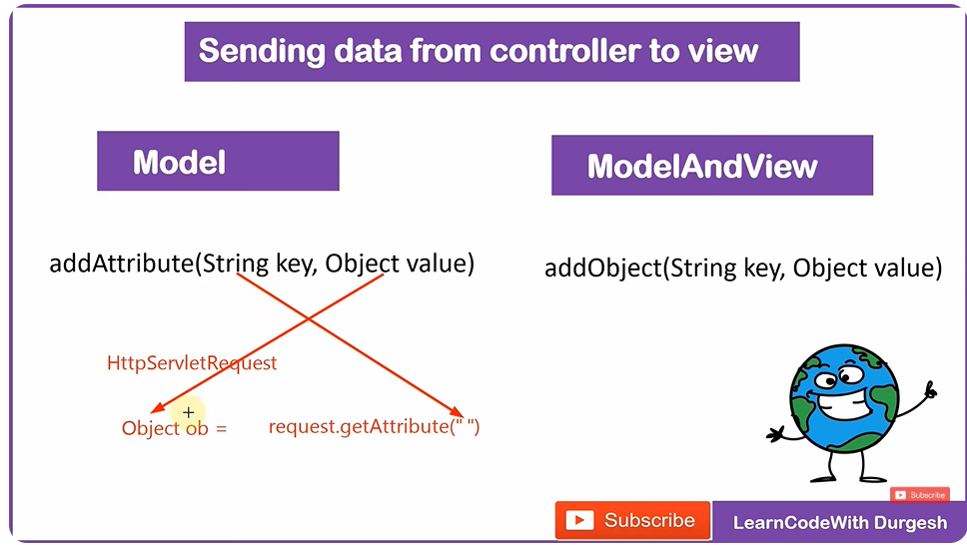
We will be using model object in model method
Heres simple implementation
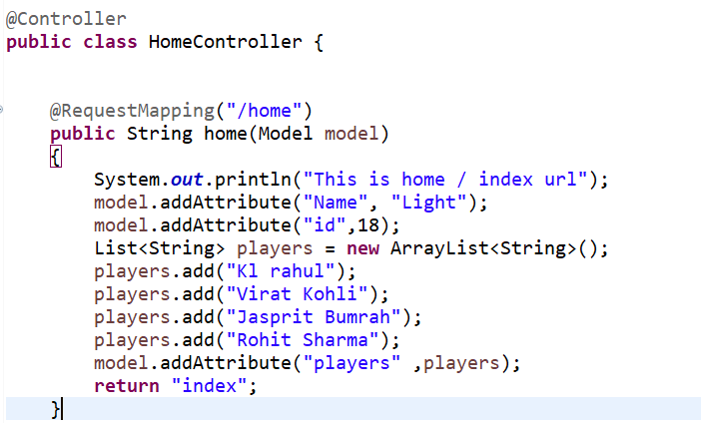
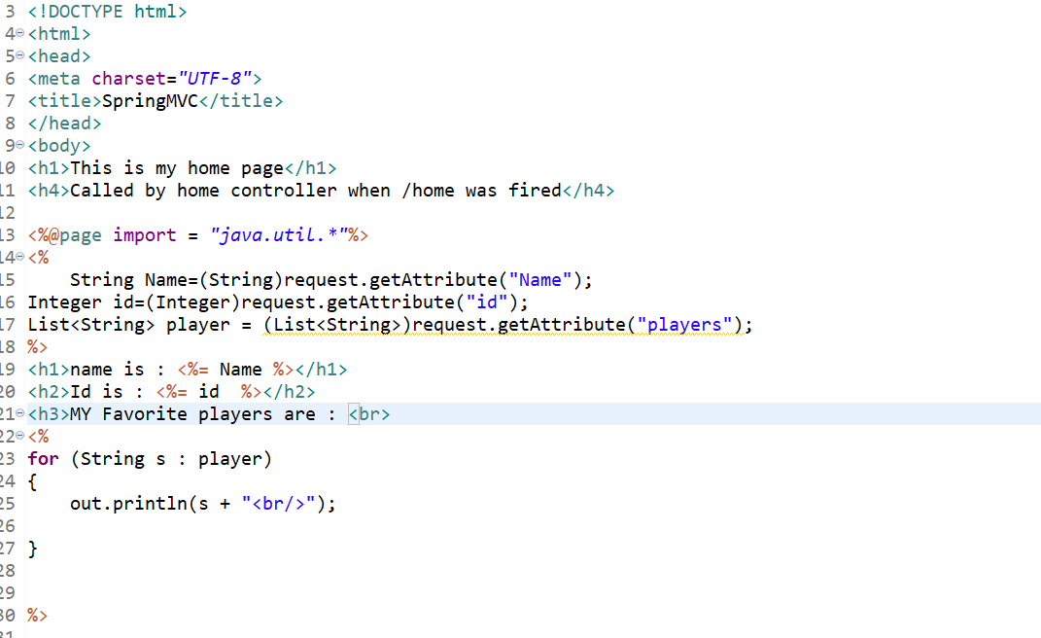

Now
ModelAndView | Sending Data from controller to View | Spring MVC Tutorial

Using ModelAndView to Send Data from Controller to View in Spring MVC
In Spring MVC, ModelAndView is a powerful way to send both the model (data) and view (presentation) in a single object. This approach allows you to encapsulate both the logic and the view handling in one return type. It's a common and efficient way to transfer data from the controller to the view in Spring MVC applications.

What is ModelAndView?
- ModelAndView is a Spring MVC class that contains both the model (data) and the view (the logical name of the view).
- It can be returned from a controller method to pass data (model) to a specific view.

How ModelAndView Works:
- Model: Contains the data (like a Map) that needs to be passed to the view.
- View: A reference to the logical name of the view (e.g., JSP, Thymeleaf).
- When the controller method returns ModelAndView, Spring automatically resolves the view using a ViewResolver and binds the model data to the view.

Steps to Send Data Using ModelAndView

1. Controller
In the controller, the ModelAndView object is created and populated with both the model data and view name. The model is added as attributes using the addObject() method, and the view is specified when returning the ModelAndView object.

2. View
In the view (typically a JSP file), the model attributes can be accessed by their names (set in the controller), and they will be rendered dynamically.

Example: Using ModelAndView
Let’s walk through an example where we create a Spring MVC application that uses ModelAndView to send data from the controller to the view.

1. Create the Model Object (Student)
Create a simple model class representing a student.
java
Copy code
public class Student {
private int id;
private String name;
private String city;

// Constructor, Getters, and Setters
public Student(int id, String name, String city) {
this.id = id;
this.name = name;
this.city = city;
}

// Getters and Setters
public int getId() {
return id;
}

public void setId(int id) {
this.id = id;
}

public String getName() {
return name;
}

public void setName(String name) {
this.name = name;
}

public String getCity() {
return city;
}

public void setCity(String city) {
this.city = city;
}
}

2. Controller Using ModelAndView
In the controller, you create the ModelAndView object, set the view name, and add the Student object as a model attribute.
java
Copy code
import org.springframework.stereotype.Controller;
import org.springframework.web.bind.annotation.RequestMapping;
import org.springframework.web.servlet.ModelAndView;

@Controller
public class StudentController {

@RequestMapping("/showStudent")
public ModelAndView showStudent() {
// Create a student object
Student student = new Student(1, "John", "New York");

// Create ModelAndView object
ModelAndView modelAndView = new ModelAndView("studentView"); // "studentView" is the JSP view name

// Add student object to the model
modelAndView.addObject("student", student);

return modelAndView; // Return the ModelAndView object
}
}
In this example:
- The ModelAndView is initialized with the view name studentView, which will be resolved to a JSP page.
- The addObject() method is used to add the student object to the model, so it can be accessed in the view.

3. View (JSP)
Create the studentView.jsp file in the WEB-INF/views/ directory. This JSP file will display the student data.
jsp
Copy code
<!-- studentView.jsp -->
<html>
<body>
<h2>Student Information</h2>
<p>ID: ${student.id}</p>
<p>Name: ${student.name}</p>
<p>City: ${student.city}</p>
</body>
</html>
- The student object (added by the controller) can be accessed in the JSP using ${student.property}.
- ${student.id}, ${student.name}, and ${student.city} are dynamically replaced by the values of the student object sent by the controller.

4. web.xml Configuration
Make sure your Spring MVC configuration is set up in the web.xml to load the Spring DispatcherServlet.
xml
Copy code
<web-app>
<!-- Spring MVC Servlet -->
<servlet>
<servlet-name>spring</servlet-name>
<servlet-class>org.springframework.web.servlet.DispatcherServlet</servlet-class>
<load-on-startup>1</load-on-startup>
</servlet>

<!-- Spring MVC Servlet Mapping -->
<servlet-mapping>
<servlet-name>spring</servlet-name>
<url-pattern>/</url-pattern>
</servlet-mapping>
</web-app>
This configuration ensures that all requests are handled by the Spring DispatcherServlet, which processes and routes them according to the Spring MVC framework.

5. servlet-context.xml Configuration
Configure the InternalResourceViewResolver to resolve the JSP views.
xml
Copy code
<beans xmlns="http://www.springframework.org/schema/beans"
xmlns:xsi="http://www.w3.org/2001/XMLSchema-instance"
xsi:schemaLocation="http://www.springframework.org/schema/beans
http://www.springframework.org/schema/beans/spring-beans.xsd">

<!-- Configure view resolver -->
<bean class="org.springframework.web.servlet.view.InternalResourceViewResolver">
<property name="prefix" value="/WEB-INF/views/" />
<property name="suffix" value=".jsp" />
</bean>

</beans>
This configures the Spring InternalResourceViewResolver to look for views in the WEB-INF/views/ directory with the .jsp suffix.

How It Works:
- Request: When a user accesses the URL /showStudent, the showStudent() method in the StudentController is invoked.
- Model: The ModelAndView object is created with the student data and the view name (studentView).
- View Resolution: The InternalResourceViewResolver resolves the logical view name (studentView) to the actual JSP file studentView.jsp.
- Rendering: The model attributes (student object) are passed to the JSP, and the values are dynamically rendered in the page.

Key Points to Remember:
- ModelAndView combines both the view name and model data in one object.
- addObject() is used to pass data (model attributes) from the controller to the view.
- ViewResolver resolves the view name and maps it to the corresponding JSP (or another view technology).
- ModelAndView makes it easier to send data along with the view, as it allows both to be returned together.

Conclusion:
Using ModelAndView in Spring MVC simplifies the process of sending both the model data and the view name together. This is a powerful approach to create dynamic, data-driven web applications where both backend logic and frontend presentation are tightly integrated.
4o mini

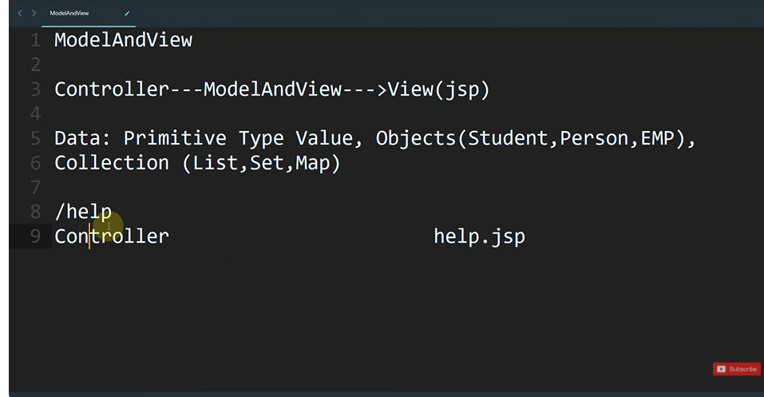
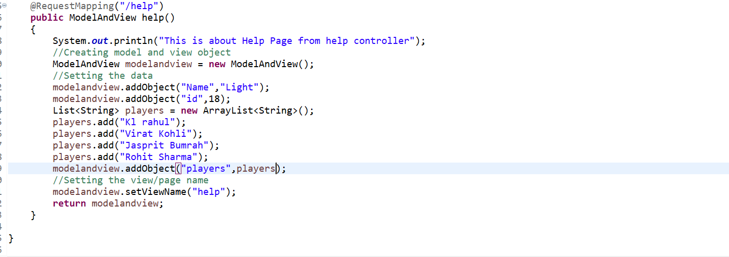
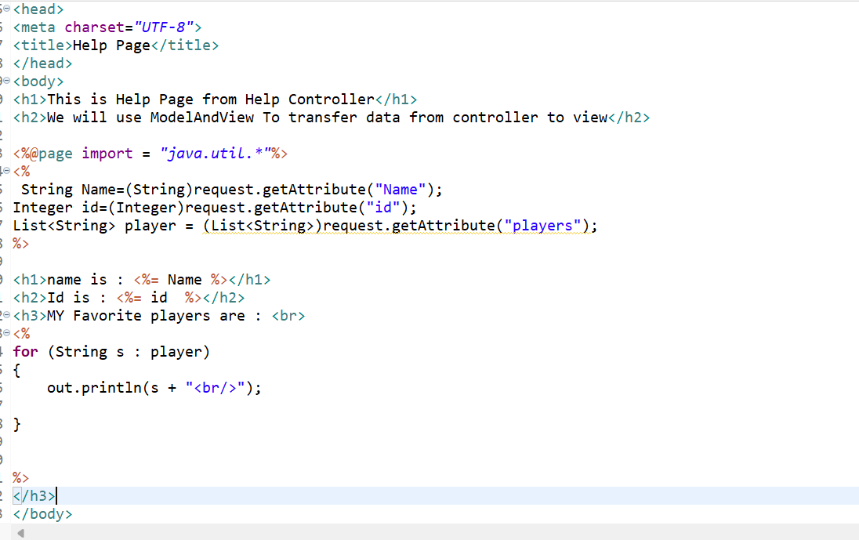
Rest all Same

Sending data from View to Controller Complete concept | Spring MVC

Basically there are three ways of getting data from view :- 1) request object 2) @RequestParam 3) @ModelAttribute

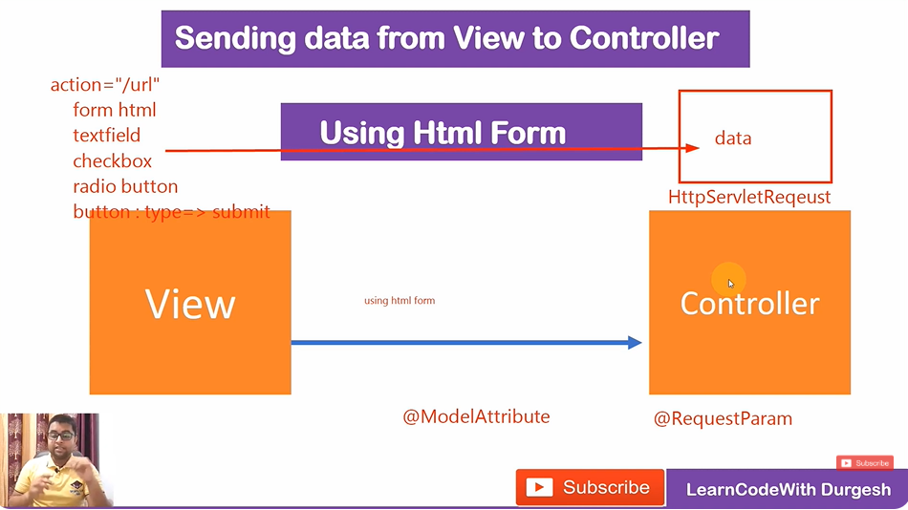
In Spring MVC, sending data from a View (e.g., JSP) to a Controller involves submitting a form or making an HTTP request. Here's a complete explanation of how this works:

Steps to Send Data from View to Controller
- Set Up the Spring MVC Configuration: Ensure your DispatcherServlet is configured in the web.xml or as part of your Java-based configuration, and a controller is mapped to handle requests.
- Define the Model (e.g., a POJO): Create a model class to map the data sent from the View.
java
Copy code
package com.spring.mvc.model;

public class User {
private String name;
private String email;
private String password;

// Getters and Setters
public String getName() {
return name;
}

public void setName(String name) {
this.name = name;
}

public String getEmail() {
return email;
}

public void setEmail(String email) {
this.email = email;
}

public String getPassword() {
return password;
}

public void setPassword(String password) {
this.password = password;
}

@Override
public String toString() {
return "User [name=" + name + ", email=" + email + ", password=" + password + "]";
}
}
- Create the Form in the View (JSP): The form collects user input and submits the data to the Controller.
jsp
Copy code
<%@ taglib uri="http://www.springframework.org/tags/form" prefix="form" %>

<html>
<body>
<h2>User Registration</h2>
<form:form action="registerUser" modelAttribute="user" method="post">
<table>
<tr>
<td>Name:</td>
<td><form:input path="name" /></td>
</tr>
<tr>
<td>Email:</td>
<td><form:input path="email" /></td>
</tr>
<tr>
<td>Password:</td>
<td><form:password path="password" /></td>
</tr>
<tr>
<td colspan="2"><input type="submit" value="Submit" /></td>
</tr>
</table>
</form:form>
</body>
</html>
- Create the Controller to Handle the Form Data: The @Controller annotation maps HTTP requests, and the @ModelAttribute binds the form data to the model object.
java
Copy code
package com.spring.mvc.controller;

import org.springframework.stereotype.Controller;
import org.springframework.web.bind.annotation.ModelAttribute;
import org.springframework.web.bind.annotation.RequestMapping;
import org.springframework.web.bind.annotation.RequestMethod;
import org.springframework.web.servlet.ModelAndView;

import com.spring.mvc.model.User;

@Controller
public class UserController {

@RequestMapping("/showForm")
public ModelAndView showForm() {
// Return the view with an empty model object
return new ModelAndView("userForm", "user", new User());
}

@RequestMapping(value = "/registerUser", method = RequestMethod.POST)
public ModelAndView registerUser(@ModelAttribute("user") User user) {
// Print or process the user object
System.out.println("User details: " + user);

// Send the user data back to a view
ModelAndView mv = new ModelAndView("success");
mv.addObject("user", user);
return mv;
}
}
- Define the Success View (JSP): Create a JSP to display the submitted data.
jsp
Copy code
<html>
<body>
<h2>Registration Successful</h2>
<p>Name: ${user.name}</p>
<p>Email: ${user.email}</p>
<p>Password: ${user.password}</p>
</body>
</html>
- Configure Spring MVC in servlet-context.xml or Java-based Config:
XML-based Configuration:
xml
Copy code
<context:component-scan base-package="com.spring.mvc.controller" />
<bean
class="org.springframework.web.servlet.view.InternalResourceViewResolver">
<property name="prefix" value="/WEB-INF/views/" />
<property name="suffix" value=".jsp" />
</bean>
Java-based Configuration:
java
Copy code
@Configuration
@EnableWebMvc
@ComponentScan("com.spring.mvc.controller")
public class WebConfig implements WebMvcConfigurer {
@Bean
public InternalResourceViewResolver viewResolver() {
InternalResourceViewResolver resolver = new InternalResourceViewResolver();
resolver.setPrefix("/WEB-INF/views/");
resolver.setSuffix(".jsp");
return resolver;
}
}

Workflow Explanation:
- View (JSP): The user fills in a form, which sends data to the Controller via an HTTP POST request.
- Controller:
  - The @ModelAttribute binds the form data to the User model.
  - The controller processes the model (e.g., logs it or persists it in a database).
  - It sends data back to the View using a ModelAndView.
- View: The JSP retrieves the data sent by the controller and displays it.

Advantages of this Approach:
- Clean separation between View, Controller, and Model.
- @ModelAttribute simplifies data binding between the form and the object.
- Extensible to other features like validation and error handling using annotations like @Valid.

@Request Mapping Annotation in Spring MVC
The @RequestMapping annotation in Spring MVC is used to map web requests to specific handler methods or classes in your controller. It is a versatile and powerful annotation that can define request URLs, HTTP methods, request parameters, headers, and more.

Key Features of @RequestMapping
- Mapping URLs: Specifies the path for which the handler method or controller class is responsible.
- HTTP Methods: Supports mapping specific HTTP methods like GET, POST, PUT, DELETE, etc.
- Request Parameters: Maps requests based on query parameters.
- Headers: Matches requests based on headers.

Usage of @RequestMapping

1. Mapping at the Class Level
You can define a base URL for all methods in a controller by placing @RequestMapping at the class level.
java
Copy code
@Controller
@RequestMapping("/users")
public class UserController {
@RequestMapping("/list")
public String listUsers() {
return "userList";
}
}
Here, the listUsers method will respond to /users/list.

2. Mapping at the Method Level
The method-level @RequestMapping is used for specific URL patterns.
java
Copy code
@Controller
public class UserController {
@RequestMapping("/home")
public String homePage() {
return "home";
}
}
This maps /home to the homePage method.

3. Mapping Specific HTTP Methods
To handle specific HTTP methods, use the method attribute.
java
Copy code
@RequestMapping(value = "/save", method = RequestMethod.POST)
public String saveUser() {
// Logic to save a user
return "success";
}
Alternatively, you can use shorthand annotations introduced in Spring 4.3:
- @GetMapping
- @PostMapping
- @PutMapping
- @DeleteMapping
- @PatchMapping
Example:
java
Copy code
@GetMapping("/view")
public String viewUser() {
return "userView";
}

4. Mapping Request Parameters
You can match specific query parameters using the params attribute.
java
Copy code
@RequestMapping(value = "/filter", params = "type=admin")
public String filterAdmins() {
return "adminList";
}
This maps /filter?type=admin.

5. Mapping Request Headers
You can match requests based on HTTP headers using the headers attribute.
java
Copy code
@RequestMapping(value = "/api", headers = "content-type=application/json")
public String handleJson() {
return "jsonView";
}

6. Using Path Variables
You can extract dynamic values from the URL using @PathVariable.
java
Copy code
@RequestMapping("/user/{id}")
public String getUser(@PathVariable("id") int userId) {
System.out.println("User ID: " + userId);
return "userDetail";
}
Here, /user/123 would pass 123 as the userId.

7. Combining Request Parameters and Path Variables
You can mix query parameters and path variables.
java
Copy code
@RequestMapping("/user/{id}/edit")
public String editUser(@PathVariable int id, @RequestParam String name) {
System.out.println("Editing user " + id + " with name: " + name);
return "editSuccess";
}
A request like /user/5/edit?name=John would extract id=5 and name=John.

8. Mapping Wildcards and Ant Patterns
- * matches one segment of the path.
- ** matches zero or more segments.
Example:
java
Copy code
@RequestMapping("/docs/*")
public String singleSegment() {
return "singleSegment";
}

@RequestMapping("/docs/**")
public String multiSegment() {
return "multiSegment";
}

9. Mapping with Consumes and Produces
You can specify the type of content the method can consume or produce.
java
Copy code
@RequestMapping(value = "/json", consumes = "application/json", produces = "application/json")
public @ResponseBody User handleJsonRequest(@RequestBody User user) {
return user;
}

Example Controller with @RequestMapping
java
Copy code
@Controller
@RequestMapping("/products")
public class ProductController {

@GetMapping("/{id}")
public String getProduct(@PathVariable int id) {
System.out.println("Product ID: " + id);
return "productDetail";
}

@PostMapping("/save")
public String saveProduct(@RequestParam String name, @RequestParam double price) {
System.out.println("Saving Product: " + name + ", Price: " + price);
return "success";
}

@RequestMapping(value = "/filter", params = "category")
public String filterProducts(@RequestParam String category) {
System.out.println("Filtering category: " + category);
return "filteredProducts";
}
}

Summary
- @RequestMapping is a core annotation for mapping URLs to controller methods.
- It supports advanced configurations like HTTP methods, path variables, query parameters, headers, and content types.
- In modern Spring applications, prefer using the shorthand annotations like @GetMapping and @PostMapping.
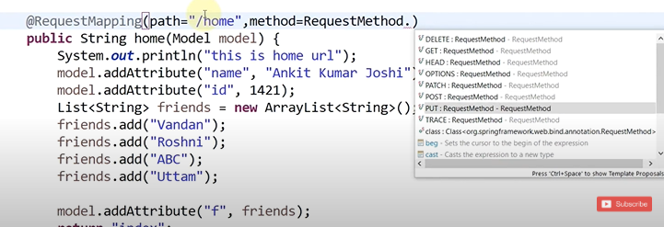
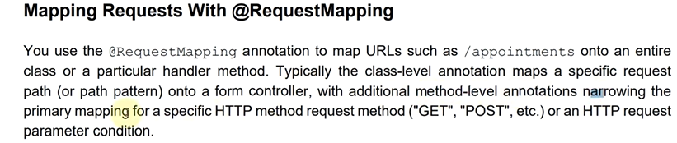

Creating Html Form to Take Input from user and Send to Controller | Spring MVC
o create an HTML form that takes user input and sends it to a Spring MVC controller, you need to follow these steps:

Steps to Implement
- Create an HTML Form in JSP
  - This form will collect data from the user and submit it to a controller.
- Define a Model Class
  - Use a model class to hold the data from the form.
- Write the Controller Method
  - The controller will map the form's request and handle the submitted data.
- Configure Spring MVC
  - Ensure the DispatcherServlet, view resolver, and controller configurations are set up properly.
- Test the Setup

Step-by-Step Example

1. Model Class
Define a class to hold the user input. For example:
java
Copy code
package com.springmvc.model;

public class User {
private String name;
private String email;

// Getters and Setters
public String getName() {
return name;
}
public void setName(String name) {
this.name = name;
}
public String getEmail() {
return email;
}
public void setEmail(String email) {
this.email = email;
}
}

2. HTML Form in JSP
Create a form in a JSP file (userForm.jsp) to take user input:
html
Copy code
<!DOCTYPE html>
<html>
<head>
<title>User Form</title>
</head>
<body>
<h1>Enter User Details</h1>
<form action="processForm" method="post">
<label for="name">Name:</label>
<input type="text" id="name" name="name" required><br><br>
<label for="email">Email:</label>
<input type="email" id="email" name="email" required><br><br>
<button type="submit">Submit</button>
</form>
</body>
</html>

3. Controller
Create a controller to handle the form submission:
java
Copy code
package com.springmvc.controller;

import org.springframework.stereotype.Controller;
import org.springframework.web.bind.annotation.ModelAttribute;
import org.springframework.web.bind.annotation.PostMapping;
import org.springframework.web.servlet.ModelAndView;

import com.springmvc.model.User;

@Controller
public class UserController {

@PostMapping("/processForm")
public ModelAndView processForm(@ModelAttribute User user) {
// Handle the submitted data
ModelAndView mv = new ModelAndView("userSuccess");
mv.addObject("user", user);
return mv;
}
}

4. Success Page
Create a JSP file (userSuccess.jsp) to display the submitted data:
html
Copy code
<!DOCTYPE html>
<html>
<head>
<title>Success</title>
</head>
<body>
<h1>Form Submitted Successfully</h1>
<p>Name: ${user.name}</p>
<p>Email: ${user.email}</p>
</body>
</html>

5. Spring Configuration
Ensure your web.xml is configured correctly:
xml
Copy code
<web-app>
<servlet>
<servlet-name>spring</servlet-name>
<servlet-class>org.springframework.web.servlet.DispatcherServlet</servlet-class>
</servlet>

<servlet-mapping>
<servlet-name>spring</servlet-name>
<url-pattern>/</url-pattern>
</servlet-mapping>
</web-app>
And in your spring-servlet.xml file:
xml
Copy code
<bean class="org.springframework.web.servlet.view.InternalResourceViewResolver">
<property name="prefix" value="/WEB-INF/views/" />
<property name="suffix" value=".jsp" />
</bean>
Place your JSP files in the /WEB-INF/views/ directory.

How It Works
- The user accesses the userForm.jsp and fills out the form.
- The form submits data to the /processForm URL.
- The controller maps this URL, processes the data, and sends it to the userSuccess.jsp page for display.

Folder Structure
css
Copy code
src/main/java
├── com.springmvc.controller
│ └── UserController.java
├── com.springmvc.model
│ └── User.java

WEB-INF
├── views
│ ├── userForm.jsp
│ └── userSuccess.jsp
├── web.xml
├── spring-servlet.xml

OUR BASIC THING WILL BE BELOW

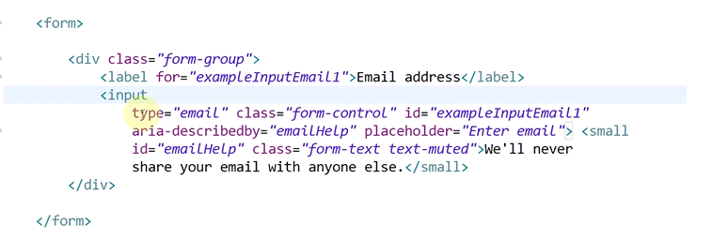
Now a controller
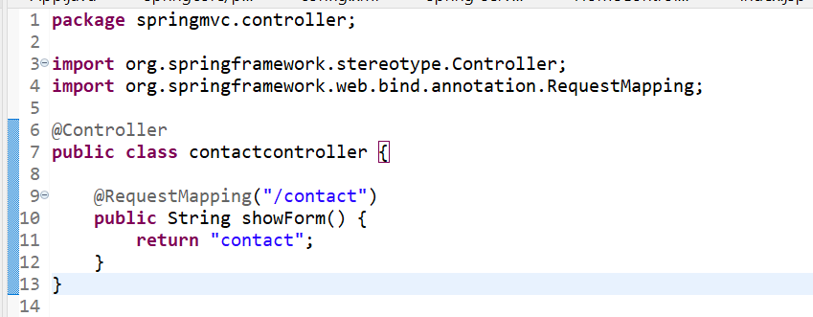
Handling Form at Spring MVC Controller using @RequestParam Annotation | Spring MVC
In Spring MVC, you can handle form data in the controller using the @RequestParam annotation. Here's an example:

1. Form (HTML)
html
Copy code
<!DOCTYPE html>
<html>
<head>
<title>Contact Form</title>
</head>
<body>
<form action="/handleForm" method="post">
<label for="name">Name:</label>
<input type="text" id="name" name="name"><br><br>

<label for="email">Email:</label>
<input type="email" id="email" name="email"><br><br>

<input type="submit" value="Submit">
</form>
</body>
</html>

2. Controller
java
Copy code
@Controller
public class ContactController {

@RequestMapping("/contact")
public String showForm() {
return "contact"; // Loads the contact.jsp view
}

@RequestMapping(value = "/handleForm", method = RequestMethod.POST)
public String handleForm(
@RequestParam("name") String name,
@RequestParam("email") String email,
Model model) {

// Add the form data to the model to display it in the view
model.addAttribute("name", name);
model.addAttribute("email", email);

// Redirect to a confirmation or success page
return "success";
}
}

3. Success View (success.jsp)
html
Copy code
<!DOCTYPE html>
<html>
<head>
<title>Form Submitted</title>
</head>
<body>
<h1>Form Submitted Successfully!</h1>
<p>Name: ${name}</p>
<p>Email: ${email}</p>
</body>
</html>

Explanation of @RequestParam:
- The @RequestParam annotation is used to bind form input fields (e.g., name and email) to method parameters in the controller.
- The Model object is used to pass data from the controller to the view.
- The success.jsp page displays the submitted data back to the user.
Now our things
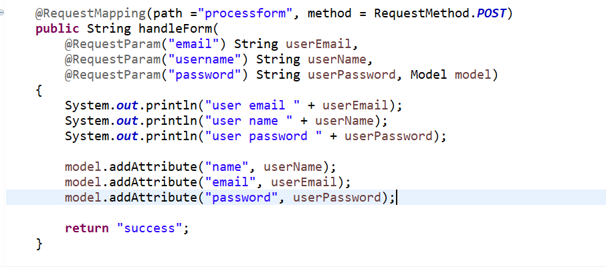
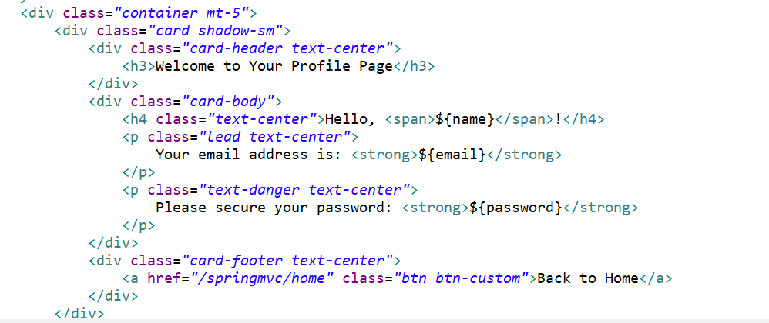

Handling Form with @ModelAttribute Annotation | @ModelAttribute Annoation

n Spring MVC, the @ModelAttribute annotation is used to bind form data to a model object. It plays a key role in handling form submissions by mapping the form inputs (from HTML) to an object in the backend (usually a Java bean). Here's how the @ModelAttribute annotation works in Spring MVC.

Key Points about @ModelAttribute:
- Binding Form Data to Java Object:
  - The @ModelAttribute annotation binds the form fields to a model object automatically.
  - If a form is submitted, Spring MVC uses the provided model class and binds the request parameters to the model's fields.
- Form Submission:
  - When a form is submitted, the form fields' values are passed as request parameters. The @ModelAttribute annotation tells Spring MVC to populate a Java object (usually a POJO) with the form data.
- Usage:
  - You can use @ModelAttribute both at the method level (to add an attribute to the model before the controller method is invoked) and at the parameter level (to bind form data to a model object in the controller method).

Example of @ModelAttribute in a Form Handling Scenario:

Step 1: Define a Java Model Class
java
Copy code
public class User {
private String name;
private int age;
private String department;

// Getters and Setters
}

Step 2: Create a Spring MVC Controller
java
Copy code
@Controller
public class UserController {

// Display the form
@GetMapping("/showForm")
public String showForm(Model model) {
model.addAttribute("user", new User());
return "userForm";
}

// Handle form submission
@PostMapping("/submitForm")
public String submitForm(@ModelAttribute("user") User user, Model model) {
model.addAttribute("message", "User data received: " + user.getName() + ", " + user.getAge() + ", " + user.getDepartment());
return "result";
}
}
- @GetMapping("/showForm"): Displays the form when the user navigates to the URL /showForm.
- @PostMapping("/submitForm"): Handles the form submission. The @ModelAttribute("user") binds the form fields to a User object.

Step 3: Create a JSP Form (userForm.jsp)
jsp
Copy code
<form action="/submitForm" method="post">
<label for="name">Name:</label>
<input type="text" id="name" name="name" value="${user.name}" required>

<label for="age">Age:</label>
<input type="text" id="age" name="age" value="${user.age}" required>

<label for="department">Department:</label>
<input type="text" id="department" name="department" value="${user.department}" required>

<input type="submit" value="Submit">
</form>

Step 4: Create a JSP to Display the Result (result.jsp)
jsp
Copy code
<p>${message}</p>

How It Works:
- Form Display: When the /showForm URL is accessed, Spring MVC initializes a new User object and adds it to the model. The form fields (name, age, department) are populated with this empty User object.
- Form Submission: When the form is submitted, Spring MVC binds the submitted data to the User object in the @ModelAttribute annotation and passes it to the submitForm method. The User object is populated with the form data.
- Display the Result: After the form submission, the controller returns a view (result.jsp) that displays the submitted data.

Advantages of @ModelAttribute:
- Simplifies Form Handling: It reduces the need for manually extracting form parameters and setting them to the model object.
- Supports Complex Types: It works not only with simple types but also with complex objects and even lists or maps.
- Automatic Validation: If validation annotations (like @Valid or @NotNull) are added to the model, Spring will automatically validate the input.

Conclusion:
The @ModelAttribute annotation in Spring MVC is a powerful tool to handle form data binding. It simplifies the process of populating model objects from form fields, making it easier to manage form submissions in a structured and maintainable way.
4o mini

O

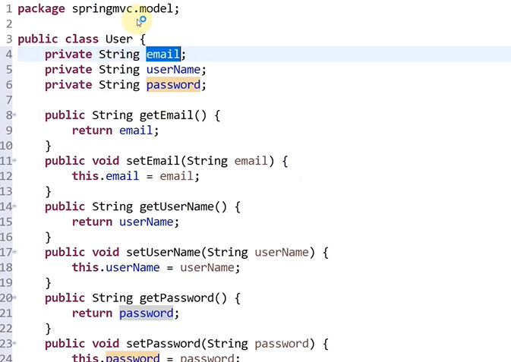

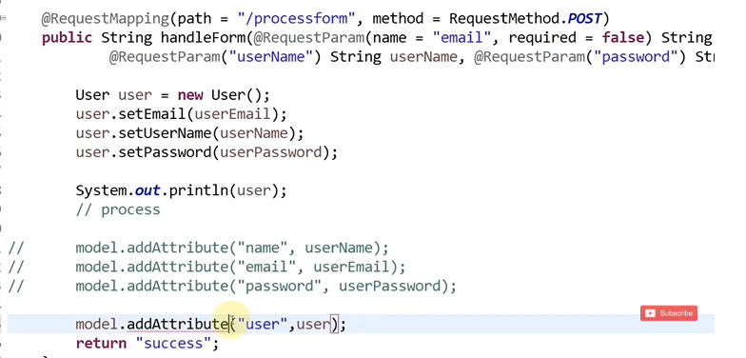
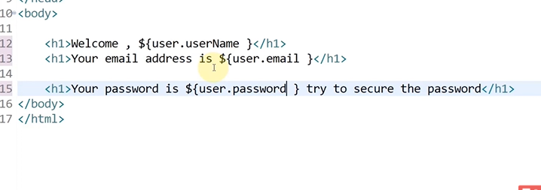
Now will see model attribute
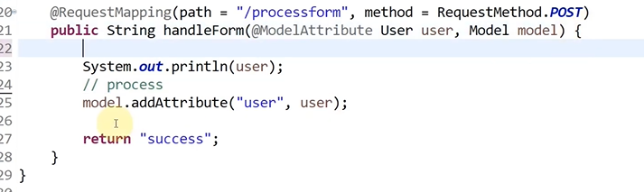
Simple

User Registration using Spring MVC and Spring ORM | Spring MVC Tutorial
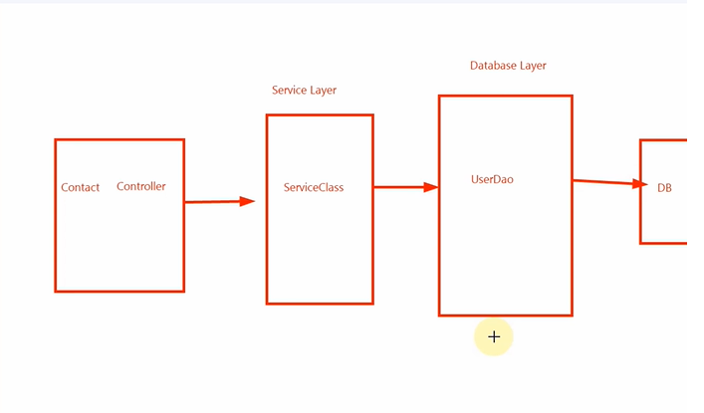
We will be doing autowiring here
@Service @Repository @transactional
In Spring Framework, annotations like @Repository, @Service, and @Autowired are part of the core of Spring's dependency injection and component scanning mechanisms. These annotations help define beans and manage dependencies in a clean, declarative way.

1. @Repository
The @Repository annotation is used to indicate that a class is a Data Access Object (DAO) component, typically used for database operations. It serves as a specialization of the @Component annotation and is used to mark a class whose purpose is to interact with a data store (such as a database).

Key Points:
- It is typically used in the persistence layer.
- Marks the class as a Spring-managed bean for automatic component scanning.
- In addition to marking a class as a Spring bean, it provides additional behavior related to persistence, such as exception translation.
  - Spring wraps exceptions (such as SQLException) into unchecked exceptions (like DataAccessException), making error handling easier.

Example:
java
Copy code
import org.springframework.stereotype.Repository;

@Repository
public class UserDao {

public void saveUser(User user) {
// Database interaction logic (using Hibernate/JDBC, etc.)
}
}
In the above example, the UserDao class is marked as a repository to indicate it performs database operations. Spring will automatically register this class as a bean, making it available for dependency injection.

2. @Service
The @Service annotation is used to define a service class, which typically holds the business logic in your application. It is another specialization of the @Component annotation, similar to @Repository and @Controller.

Key Points:
- It is typically used in the service layer, where business logic resides.
- Like @Repository, it registers the class as a Spring bean, enabling dependency injection.
- Spring doesn’t provide any additional functionality for @Service classes compared to @Component, but it is used for clarity and to indicate that the class holds business logic.

Example:
java
Copy code
import org.springframework.stereotype.Service;

@Service
public class UserService {

private final UserDao userDao;

// Constructor-based injection
public UserService(UserDao userDao) {
this.userDao = userDao;
}

public void registerUser(User user) {
// Some business logic
userDao.saveUser(user);
}
}
In the example above, the UserService class is responsible for business logic related to users and is marked as a @Service to indicate its role in the service layer.

3. @Autowired
The @Autowired annotation is used to automatically inject dependencies into a Spring bean. It tells Spring to resolve and inject the required dependency into the class at runtime.

Key Points:
- It can be used on fields, constructors, or setter methods.
- Spring performs dependency injection (DI), which means Spring automatically wires the required dependencies.
- By default, @Autowired performs by type injection. Spring will inject the dependency that matches the type of the field, constructor, or setter method.

Example with Field Injection:
java
Copy code
import org.springframework.beans.factory.annotation.Autowired;
import org.springframework.stereotype.Controller;

@Controller
public class UserController {

@Autowired
private UserService userService;

public void registerUser(User user) {
userService.registerUser(user);
}
}
In this example, Spring will automatically inject an instance of UserService into the UserController class. It is important to note that @Autowired requires the appropriate bean to be available in the application context (i.e., a @Service, @Component, etc., annotated class).

Example with Constructor Injection (Recommended Approach):
java
Copy code
import org.springframework.beans.factory.annotation.Autowired;
import org.springframework.stereotype.Controller;

@Controller
public class UserController {

private final UserService userService;

@Autowired
public UserController(UserService userService) {
this.userService = userService;
}

public void registerUser(User user) {
userService.registerUser(user);
}
}
Constructor injection is considered a best practice in Spring because it ensures that the required dependencies are provided at the time of object creation, promoting immutability and making unit testing easier.

Example with Setter Injection:
java
Copy code
import org.springframework.beans.factory.annotation.Autowired;
import org.springframework.stereotype.Controller;

@Controller
public class UserController {

private UserService userService;

@Autowired
public void setUserService(UserService userService) {
this.userService = userService;
}

public void registerUser(User user) {
userService.registerUser(user);
}
}
Setter injection is another way to inject dependencies, though it is less favored than constructor injection, especially for mandatory dependencies.

How Dependency Injection Works with @Autowired:
- By Type: Spring resolves the dependency by matching the type of the field, constructor parameter, or setter method with the available beans in the application context.
- By Name (optional): If there are multiple beans of the same type, you can use the @Qualifier annotation to specify the exact bean to inject.

Example of @Autowired with @Qualifier:
java
Copy code
@Autowired
@Qualifier("userDao")
private UserDao userDao;
This tells Spring to inject the userDao bean by name, resolving conflicts if multiple beans of the same type are present.

Conclusion:
- @Repository: Marks a class as a DAO that interacts with the database and provides additional behavior related to persistence (like exception translation).
- @Service: Marks a class as a service that contains business logic, and it is a specialization of @Component.
- @Autowired: Used for automatic dependency injection, allowing Spring to inject the required dependencies at runtime.
These annotations help Spring manage the application's layers, promote loose coupling, and ensure that dependencies are injected automatically.
In Spring, the @Transactional annotation is used to define transaction boundaries in a method or class. It is a part of the Spring Framework's declarative transaction management mechanism, and it allows you to manage database transactions with minimal configuration.

Purpose of @Transactional
The @Transactional annotation is used to ensure that a method or class executes within a transaction context. A transaction typically involves multiple database operations, and the purpose of a transaction is to ensure that either all of these operations are committed (successfully saved) to the database, or none of them are, in case of a failure (rollback). This is often referred to as the ACID properties of transactions (Atomicity, Consistency, Isolation, Durability).

Key Points
- Atomicity: The transaction is atomic, meaning that all operations in the transaction are executed as one single unit. If any part of the transaction fails, the entire transaction is rolled back.
- Consistency: The database remains in a consistent state before and after the transaction.
- Isolation: Transactions are isolated from each other. The changes made by one transaction are not visible to others until the transaction is committed.
- Durability: Once a transaction is committed, its changes are permanent and will not be lost, even in the case of a system crash.

Using @Transactional
The @Transactional annotation can be applied at the class or method level.

1. Method Level Transaction Management
At the method level, you can define a transaction boundary for a specific method. For example, the following example ensures that the registerUser() method is executed within a transaction.
java
Copy code
import org.springframework.stereotype.Service;
import org.springframework.transaction.annotation.Transactional;

@Service
public class UserService {

@Transactional
public void registerUser(User user) {
userDao.save(user); // save the user to the database
// other operations
}
}
In the example above, if the save() method fails or an exception is thrown within the registerUser() method, the transaction will be rolled back, and the changes will not be committed to the database.

2. Class Level Transaction Management
You can also apply @Transactional at the class level to ensure that all methods within the class are transactional.
java
Copy code
import org.springframework.stereotype.Service;
import org.springframework.transaction.annotation.Transactional;

@Service
@Transactional
public class UserService {

public void registerUser(User user) {
userDao.save(user);
// other operations
}

public void updateUser(User user) {
userDao.update(user);
// other operations
}
}
In this case, every method in the UserService class will be executed within a transaction. However, you can override this for specific methods by providing custom settings at the method level.

Key Attributes of @Transactional
@Transactional provides several attributes that allow you to customize transaction behavior:
- propagation: Defines how transactions should be propagated if there is an existing transaction. The default value is Propagation.REQUIRED.
  - Propagation.REQUIRED: If there is an existing transaction, the method joins it. If no transaction exists, a new one is created.
  - Propagation.REQUIRES_NEW: Always starts a new transaction, suspending any existing transaction.
  - Propagation.SUPPORTS: Supports the current transaction, but doesn't require one.
  - Propagation.MANDATORY: Requires an existing transaction, throws an exception if none exists.
  - Propagation.NOT_SUPPORTED: Executes without a transaction, suspending any existing transaction.
  - Propagation.NEVER: Executes without a transaction, throws an exception if a transaction exists.
Example:
java
Copy code
@Transactional(propagation = Propagation.REQUIRES_NEW)
public void someMethod() {
// This method will always start a new transaction
}
- isolation: Defines the level of isolation for the transaction. This controls how changes made by one transaction are visible to other transactions.
  - Isolation.READ_UNCOMMITTED: Allows reading uncommitted changes from other transactions.
  - Isolation.READ_COMMITTED: Only allows reading committed changes from other transactions.
  - Isolation.REPEATABLE_READ: Prevents non-repeatable reads by ensuring that the data read during a transaction cannot be changed by other transactions before the transaction is committed.
  - Isolation.SERIALIZABLE: Provides the highest level of isolation, ensuring that no other transactions can access the data until the current transaction is complete.
Example:
java
Copy code
@Transactional(isolation = Isolation.READ_COMMITTED)
public void someMethod() {
// This method will have READ_COMMITTED isolation level
}
- rollbackFor: Specifies which exceptions should cause a rollback. By default, Spring will only rollback on unchecked exceptions (subclasses of RuntimeException) and Error. You can specify other exceptions to trigger a rollback.
Example:
java
Copy code
@Transactional(rollbackFor = {SQLException.class})
public void someMethod() {
// This method will cause a rollback if SQLException is thrown
}
- noRollbackFor: Specifies exceptions that should not cause a rollback.
Example:
java
Copy code
@Transactional(noRollbackFor = {SomeSpecificException.class})
public void someMethod() {
// This method will not rollback on SomeSpecificException
}
- timeout: Specifies the timeout for the transaction in seconds. If the transaction does not complete within the specified time, it will be rolled back.
Example:
java
Copy code
@Transactional(timeout = 30) // 30 seconds timeout
public void someMethod() {
// This method will be rolled back if it takes more than 30 seconds
}
- readOnly: If set to true, it marks the transaction as read-only, which can optimize performance for read-only operations. No write operations should be performed within a read-only transaction.
Example:
java
Copy code
@Transactional(readOnly = true)
public void someReadMethod() {
// This method should only perform read operations
}

Example: Using @Transactional in a Service Layer
Here's a full example where @Transactional is used to handle user registration and user update operations within a transactional context:
java
Copy code
import org.springframework.stereotype.Service;
import org.springframework.transaction.annotation.Transactional;

@Service
public class UserService {

private final UserDao userDao;

// Constructor-based dependency injection
public UserService(UserDao userDao) {
this.userDao = userDao;
}

@Transactional
public void registerUser(User user) {
// Perform database operations
userDao.save(user);
// other logic
}

@Transactional(propagation = Propagation.REQUIRES_NEW)
public void updateUser(User user) {
// Perform update operation in a new transaction
userDao.update(user);
}
}

Summary
- @Transactional provides a declarative way to manage transactions in Spring.
- You can apply it at the class or method level to define transaction boundaries.
- Key attributes like propagation, isolation, rollbackFor, timeout, and readOnly allow you to customize transaction behavior.
- It ensures that the changes are either committed or rolled back based on the success or failure of the operations inside the transaction.
4o mini
NOW WILL BE ADDING PRINTOUT FILE FOR
SPRINGMVC USER REGISTRATION WITH SPRING ORM
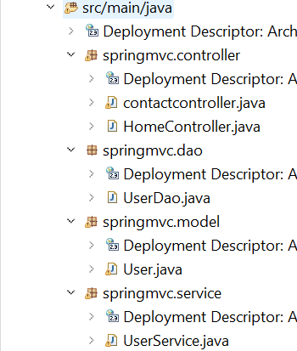
UserService.java
package springmvc.service;
import org.springframework.beans.factory.annotation.Autowired;
import org.springframework.stereotype.Service;

import springmvc.dao.*;
import springmvc.model.User;
import springmvc.service.*;
@Service
public class UserService {
@Autowired
private UserDao userdao;
public int CreateUser(User user) {
return this.userdao.SaveUser(user);
}

}

User.java
package springmvc.model;

import javax.persistence.Entity;
import javax.persistence.GeneratedValue;
import javax.persistence.GenerationType;
import javax.persistence.Id;

import org.hibernate.annotations.Table;

@Entity
@javax.persistence.Table(name="UserRegistration")
public class User {
@Id
@GeneratedValue(strategy = GenerationType.AUTO)
private int id;
private String email;
private String username;
private String password;
public String getEmail() {
return email;
}
public void setEmail(String email) {
this.email = email;
}
public String getUsername() {
return username;
}
public void setUsername(String username) {
this.username = username;
}
public String getPassword() {
return password;
}
public void setPassword(String password) {
this.password = password;
}
public User(String email, String username, String password) {
super();
this.email = email;
this.username = username;
this.password = password;
}
public User() {
super();
// TODO Auto-generated constructor stub
}
@Override
public String toString() {
return "User [email=" + email + ", username=" + username + ", password=" + password + ", getEmail()="
+ getEmail() + ", getUsername()=" + getUsername() + ", getPassword()=" + getPassword() + ", getClass()="
+ getClass() + ", hashCode()=" + hashCode() + ", toString()=" + super.toString() + "]";
}

}

UserDao.java
package springmvc.dao;

import org.springframework.beans.factory.annotation.Autowired;
import org.springframework.orm.hibernate5.HibernateTemplate;
import org.springframework.stereotype.Repository;
import org.springframework.transaction.annotation.Transactional;

import springmvc.model.User;
@Repository

public class UserDao {
@Autowired
private HibernateTemplate hibernatetemplate;
@Transactional
public int SaveUser(User user)

{
int id=(Integer)this.hibernatetemplate.save(user);
return id;
}

}

ContactController.java
package springmvc.controller;

import org.springframework.beans.factory.annotation.Autowired;
import org.springframework.stereotype.Controller;
import org.springframework.ui.Model;
import org.springframework.web.bind.annotation.ModelAttribute;
import org.springframework.web.bind.annotation.RequestMapping;
import org.springframework.web.bind.annotation.RequestMethod;
import org.springframework.web.bind.annotation.RequestParam;

import springmvc.model.User;
import springmvc.service.UserService;

@Controller
public class contactcontroller {
@Autowired
private UserService userservice;

@RequestMapping("/contact")
public String showForm() {
return "contact";
}

/*
* @RequestMapping(path ="processform", method = RequestMethod.POST) public
* String handleForm(
*
* @RequestParam("email") String userEmail,
*
* @RequestParam("username") String userName,
*
* @RequestParam("password") String userPassword, Model model) {
* System.out.println("user email " + userEmail);
* System.out.println("user name " + userName);
* System.out.println("user password " + userPassword);
*
* model.addAttribute("name", userName); model.addAttribute("email", userEmail);
* model.addAttribute("password", userPassword);
*/
@RequestMapping(path ="processform", method = RequestMethod.POST)
public String handleform(@ModelAttribute("user")User user, Model model) {
System.out.println(user);
this.userservice.CreateUser(user);
model.addAttribute(user);
return "success";
}

}

Spring-servlet.xml
<?xml version="1.0" encoding="UTF-8"?>

<beans xmlns="http://www.springframework.org/schema/beans"
xmlns:xsi="http://www.w3.org/2001/XMLSchema-instance"
xmlns:context="http://www.springframework.org/schema/context"
xmlns:p="http://www.springframework.org/schema/p"
xmlns:tx="http://www.springframework.org/schema/tx"
xsi:schemaLocation="http://www.springframework.org/schema/beans
http://www.springframework.org/schema/beans/spring-beans.xsd
http://www.springframework.org/schema/context
http://www.springframework.org/schema/context/spring-context.xsd
http://www.springframework.org/schema/tx
http://www.springframework.org/schema/tx/spring-tx.xsd

">
<tx:annotation-driven></tx:annotation-driven>

<!-- Enable component scanning for controllers and other beans -->
<context:component-scan base-package="springmvc" />

<!--HibernateTemplate bean Declaration-->
<bean class="org.springframework.orm.hibernate5.HibernateTemplate" name="hibernatetemplate">

<property name="sessionFactory" ref="localbeanfactory"></property>
</bean>
<!--LocalSessionfactory bean Declaration-->
<bean class="org.springframework.orm.hibernate5.LocalSessionFactoryBean" name="localbeanfactory">

<property name="dataSource" ref="ds"></property>
<property name="hibernateProperties" >
<props>
<prop key="hibernate.dialect">org.hibernate.dialect.PostgreSQLDialect</prop>
<prop key="hibernate.show_sql">true</prop>
<prop key="hibernate.hbm2ddl.auto">update</prop>

</props>

</property>
<property name="annotatedClasses">
<list>
<value>springmvc.model.User</value>
</list></property>

</bean>
<!--Datasource bean Declaration-->
<bean class="org.springframework.jdbc.datasource.DriverManagerDataSource" name="ds">
<property name="driverClassName" value="org.postgresql.Driver"></property>
<property name="url" value="jdbc:postgresql://localhost:5432/spring"></property>
<property name="username" value="postgres"></property>
<property name="password" value="light"></property>

</bean>
<bean class="org.springframework.orm.hibernate5.HibernateTransactionManager" name="transactionManager">
<property name="sessionFactory" ref="localbeanfactory"/>
</bean>
<!-- Define ViewResolver for JSP views -->
<bean id="viewResolver" class="org.springframework.web.servlet.view.InternalResourceViewResolver">
<property name="prefix" value="/WEB-INF/views/" />
<property name="suffix" value=".jsp" />
</bean>

</beans>

Contact.jsp
<%@ page language="java" contentType="text/html; charset=UTF-8"
pageEncoding="UTF-8"%>
<!doctype html>
<html lang="en">
<head>
<!-- Required meta tags -->
<meta charset="utf-8">
<meta name="viewport" content="width=device-width, initial-scale=1, shrink-to-fit=no">

<!-- Bootstrap CSS -->
<link rel="stylesheet" href="https://cdn.jsdelivr.net/npm/bootstrap@4.0.0/dist/css/bootstrap.min.css" integrity="sha384-Gn5384xqQ1aoWXA+058RXPxPg6fy4IWvTNh0E263XmFcJlSAwiGgFAW/dAiS6JXm" crossorigin="anonymous">

<title>Contact JSP</title>
</head>
<body>
<div class="container mt-5">
<h3 class="text-center mb-4">User Registration Form</h3>
<div class="row justify-content-center">
<div class="col-md-6">
<form action="/springmvc/processform" method="post">
<div class="form-group">
<label for="email">Email Address</label>
<input
type="email"
class="form-control"
id="email"
name="email"
placeholder="Enter your email"
required>
<small id="emailHelp" class="form-text text-muted">
We'll never share your email with anyone else.
</small>
</div>
<div class="form-group">
<label for="username">User Name</label>
<input
type="text"
class="form-control"
id="username"
name="username"
placeholder="Enter your user name"
required>
</div>
<div class="form-group">
<label for="password">User Password</label>
<input
type="password"
class="form-control"
id="password"
name="password"
placeholder="Enter your password"
required
autocomplete="new-password">
</div>
<div class="text-center">
<button type="submit" class="btn btn-success">Sign Up</button>
</div>
</form>
</div>
</div>
</div>

<footer class="mt-5 text-center text-muted">
<p>&copy; 2024 Registration Form. All rights reserved.</p>
</footer>

<!-- Optional JavaScript -->
<script src="https://code.jquery.com/jquery-3.2.1.slim.min.js" integrity="sha384-KJ3o2DKtIkvYIK3UENzmM7KCkRr/rE9/Qpg6aAZGJwFDMVNA/GpGFF93hXpG5KkN" crossorigin="anonymous"></script>
<script src="https://cdn.jsdelivr.net/npm/popper.js@1.12.9/dist/umd/popper.min.js" integrity="sha384-ApNbgh9Q+Y1QKtv3Rn7W3mgPxhU9K/ScQsAP7hUibX39j7fakFPskvXusvfa0b4Q" crossorigin="anonymous"></script>
<script src="https://cdn.jsdelivr.net/npm/bootstrap@4.0.0/dist/js/bootstrap.min.js" integrity="sha384-JZR6Spejh4U02d8jOt6vLEHfe/JQGiRRSQQxSfFWpi1MquVdAyjUar5+76PVCmYl" crossorigin="anonymous"></script>
</body>
</html>

Success.jsp
<%@ page language="java" contentType="text/html; charset=UTF-8" pageEncoding="UTF-8"%>
<%@ page isELIgnored="false" %>
<!DOCTYPE html>
<html lang="en">
<head>
<meta charset="UTF-8">
<meta name="viewport" content="width=device-width, initial-scale=1, shrink-to-fit=no">

<!-- Bootstrap CSS -->
<link rel="stylesheet" href="https://cdn.jsdelivr.net/npm/bootstrap@4.0.0/dist/css/bootstrap.min.css" integrity="sha384-Gn5384xqQ1aoWXA+058RXPxPg6fy4IWvTNh0E263XmFcJlSAwiGgFAW/dAiS6JXm" crossorigin="anonymous">

<!-- Custom CSS for enhanced appearance -->
<style>
body {
background-color: #f8f9fa;
font-family: 'Arial', sans-serif;
}
.container {
max-width: 800px;
}
.card {
border-radius: 10px;
box-shadow: 0 4px 6px rgba(0,0,0,0.1);
}
.card-header {
background-color: #007bff;
color: white;
border-radius: 10px 10px 0 0;
}
.card-footer {
background-color: #f8f9fa;
border-radius: 0 0 10px 10px;
}
.card-body {
background-color: #ffffff;
border-radius: 0 0 10px 10px;
padding: 30px;
}
.btn-custom {
background-color: #007bff;
color: white;
padding: 10px 20px;
border-radius: 5px;
text-decoration: none;
}
.btn-custom:hover {
background-color: #0056b3;
}
.lead {
font-size: 1.2rem;
}
h4 span {
color: #007bff;
}
</style>

<title>ShowView Page</title>
</head>
<body>
<div class="container mt-5">
<div class="card shadow-sm">
<div class="card-header text-center">
<h3>Welcome to Your Profile Page</h3>
</div>
<div class="card-body">
<h4 class="text-center">Hello, <span>${user.username}</span>!</h4>
<p class="lead text-center">
Your email address is: <strong>${user.email}</strong>
</p>
<p class="text-danger text-center">
Please secure your password: <strong>******************</strong>
</p>
</div>
<div class="card-footer text-center">
<a href="/springmvc/home" class="btn btn-custom">Back to Home</a>
</div>
</div>
</div>

<!-- Optional JavaScript -->
<script src="https://code.jquery.com/jquery-3.2.1.slim.min.js" integrity="sha384-KJ3o2DKtIkvYIK3UENzmM7KCkRr/rE9/Qpg6aAZGJwFDMVNA/GpGFF93hXpG5KkN" crossorigin="anonymous"></script>
<script src="https://cdn.jsdelivr.net/npm/popper.js@1.12.9/dist/umd/popper.min.js" integrity="sha384-ApNbgh9Q+Y1QKtv3Rn7W3mgPxhU9K/ScQsAP7hUibX39j7fakFPskvXusvfa0b4Q" crossorigin="anonymous"></script>
<script src="https://cdn.jsdelivr.net/npm/bootstrap@4.0.0/dist/js/bootstrap.min.js" integrity="sha384-JZR6Spejh4U02d8jOt6vLEHfe/JQGiRRSQQxSfFWpi1MquVdAyjUar5+76PVCmYl" crossorigin="anonymous"></script>
</body>
</html>

Redirecting in Spring MVC | RedirectView in Spring MVC | How to redirect in spring MVC
In Spring MVC, redirecting is the process of instructing the browser to send a new request to a different URL after completing the current request. This is often used after form submissions (to prevent duplicate submissions) or to redirect users to another page.
There are two main ways to handle redirects in Spring MVC:

1. Using the redirect: Prefix in the View Name
Spring provides a special prefix, redirect:, that you can use in the return value of a controller method to indicate a redirection.

Example:
java
Copy code
@RequestMapping(path = "/submitForm", method = RequestMethod.POST)
public String handleForm(@RequestParam("name") String userName) {
// Perform operations with the submitted data
System.out.println("User name: " + userName);

// Redirect to another URL
return "redirect:/success";
}
In this example:
- The redirect:/success tells Spring MVC to issue a redirect to /success.
- The client (browser) receives a redirect HTTP response and sends a new request to /success.

2. Using the RedirectView Class
Spring also provides the RedirectView class for handling redirection in a more programmatic way.

Example:
java
Copy code
@RequestMapping(path = "/submitForm", method = RequestMethod.POST)
public RedirectView handleForm(@RequestParam("name") String userName) {
// Perform operations with the submitted data
System.out.println("User name: " + userName);

// Create a RedirectView object
RedirectView redirectView = new RedirectView();
redirectView.setUrl("/success"); // Set the redirect URL
return redirectView;
}
In this example:
- A RedirectView object is created, and its URL is set to /success.
- Spring MVC sends an HTTP redirect response to the client.

Redirect with Data (Query Parameters)
If you need to pass data during a redirect, you can append query parameters to the redirect URL.

Example with redirect: Prefix:
java
Copy code
@RequestMapping(path = "/submitForm", method = RequestMethod.POST)
public String handleForm(@RequestParam("name") String userName) {
return "redirect:/success?name=" + userName;
}

Example with RedirectView:
java
Copy code
@RequestMapping(path = "/submitForm", method = RequestMethod.POST)
public RedirectView handleForm(@RequestParam("name") String userName) {
RedirectView redirectView = new RedirectView();
redirectView.setUrl("/success?name=" + userName);
return redirectView;
}

3. Handling the Redirected Page
You need to handle the redirected request (e.g., /success) in another controller.

Example:
java
Copy code
@RequestMapping(path = "/success", method = RequestMethod.GET)
public String showSuccessPage(@RequestParam("name") String userName, Model model) {
model.addAttribute("name", userName);
return "success"; // Return the name of the view (e.g., success.jsp)
}
In this case:
- The /success controller retrieves the query parameter (name) and displays it on the redirected page.

Advantages of Redirection:
- Prevents duplicate form submissions (common in POST/Redirect/GET pattern).
- Allows the browser to send a new request to a different URL, making the workflow more user-friendly.
- Helps separate different controller logic (e.g., form handling and result display).

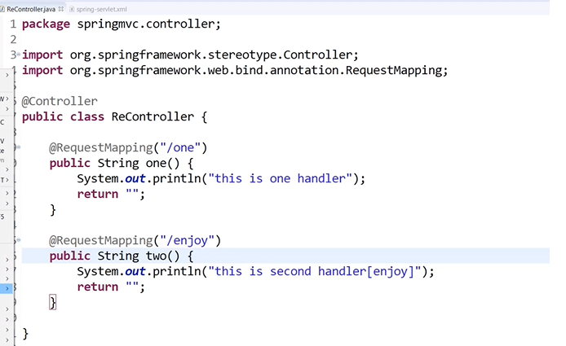
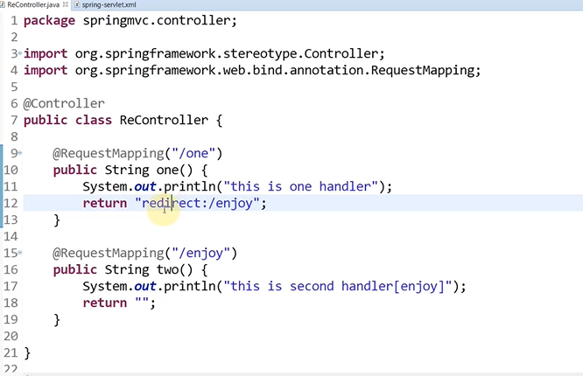
Now with redirect view
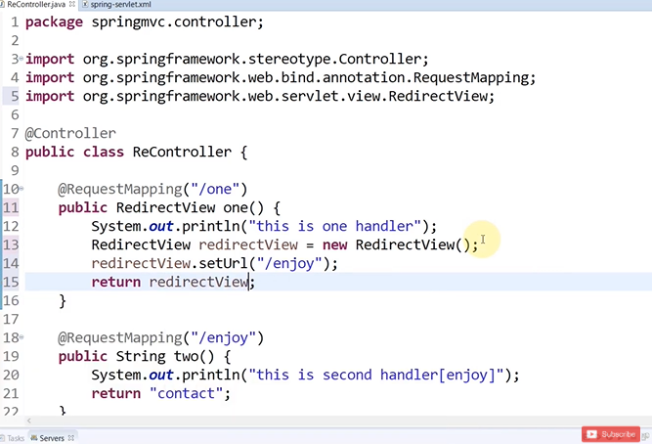

Handling Complex form in Spring MVC in one line | Spring MVC
n Spring MVC, handling complex forms efficiently is essential for applications with multiple fields, nested objects, or collections. A powerful way to handle complex forms in one line is by binding the entire form data to a model object using the @ModelAttribute annotation.

@ModelAttribute for Complex Form Binding
Instead of manually retrieving each field with @RequestParam, you can use @ModelAttribute to bind the form data directly to a Java object.

Step-by-Step Example

1. Create a Model Class
Define a model class with fields that match the form's input names.
java
Copy code
public class User {
private String name;
private String email;
private String password;

// Getters and Setters
public String getName() {
return name;
}
public void setName(String name) {
this.name = name;
}
public String getEmail() {
return email;
}
public void setEmail(String email) {
this.email = email;
}
public String getPassword() {
return password;
}
public void setPassword(String password) {
this.password = password;
}
}

2. Define the Controller
Use @ModelAttribute to bind the form data directly to the User object.
java
Copy code
@RequestMapping(path = "/submitForm", method = RequestMethod.POST)
public String handleForm(@ModelAttribute User user, Model model) {
// Print user details
System.out.println("Name: " + user.getName());
System.out.println("Email: " + user.getEmail());
System.out.println("Password: " + user.getPassword());

// Add user object to the model to pass it to the view
model.addAttribute("user", user);

return "success"; // Redirect to the success view
}

3. Create the Form
Use a form in your JSP/HTML file with input names matching the fields in the User class.
html
Copy code
<form action="submitForm" method="post">
<label>Name:</label>
<input type="text" name="name" required><br><br>

<label>Email:</label>
<input type="email" name="email" required><br><br>

<label>Password:</label>
<input type="password" name="password" required><br><br>

<button type="submit">Submit</button>
4o

O

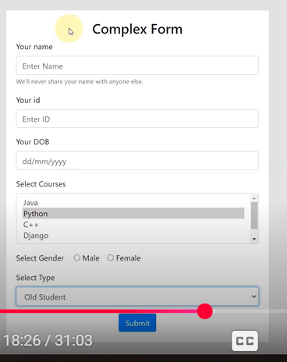
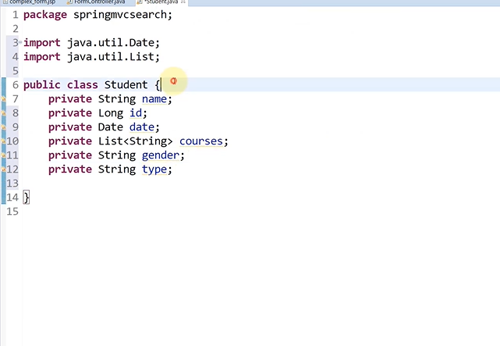
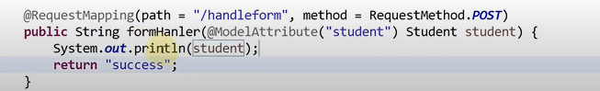
Just create and entity with names given in attributes and use model attribute annotation to fetch details

ASPECT ORIENTED PROGRAMMING
Aspect-Oriented Programming (AOP) is a programming paradigm that complements Object-Oriented Programming (OOP) by addressing cross-cutting concerns in a modular way. Cross-cutting concerns are aspects of a program that affect multiple layers or modules, such as logging, security, transaction management, caching, and error handling.
AOP allows you to define these concerns separately from the main business logic, making your code more modular, readable, and easier to maintain.

Key Concepts of AOP
- Aspect:
  - An aspect is a module that encapsulates a cross-cutting concern.
  - Example: Logging, security, or performance monitoring.
- Join Point:
  - A specific point in the execution of a program where an aspect can be applied.
  - Example: Method execution, exception handling, or field access.
- Advice:
  - The action taken by an aspect at a specific join point. It's the code that runs when a join point is reached.
  - Types of advice:
    - Before Advice: Runs before a join point.
    - After Advice: Runs after a join point.
    - Around Advice: Wraps around a join point and can control whether it proceeds or not.
    - After Returning Advice: Runs after a join point completes successfully.
    - After Throwing Advice: Runs if a method throws an exception.
- Pointcut:
  - A predicate or expression that matches join points. It specifies where the advice should be applied.
  - Example: "Apply this advice to all methods in a specific package."
- Weaving:
  - The process of linking aspects with the main code to create an advised object.
  - Types of weaving:
    - Compile-time weaving: Happens during code compilation.
    - Load-time weaving: Happens when the code is loaded into the JVM.
    - Runtime weaving: Happens dynamically during program execution.

AOP in Spring Framework
Spring AOP is a popular implementation of Aspect-Oriented Programming. It provides seamless integration of AOP into the Spring Framework.

How AOP Works in Spring
- Dependency Injection: Spring uses proxies to apply AOP concepts.
- Aspect: Defined as a class annotated with @Aspect.
- Join Points: Typically method executions in Spring.
- Pointcuts: Expressed using AspectJ expressions.
- Advice: Provided using annotations such as @Before, @After, and @Around.

Example: Logging with AOP in Spring
1. Maven Dependencies
xml
Copy code
<dependency>
<groupId>org.springframework.boot</groupId>
<artifactId>spring-boot-starter-aop</artifactId>
</dependency>
2. Aspect Class
java
Copy code
import org.aspectj.lang.annotation.Aspect;
import org.aspectj.lang.annotation.Before;
import org.springframework.stereotype.Component;

@Aspect
@Component
public class LoggingAspect {

@Before("execution(* com.example.service.*.*(..))")
public void logBeforeMethod() {
System.out.println("Method execution started...");
}
}
3. Target Class
java
Copy code
package com.example.service;

import org.springframework.stereotype.Service;

@Service
public class MyService {
public void performTask() {
System.out.println("Performing task...");
}
}
4. Application Class
java
Copy code
import org.springframework.boot.SpringApplication;
import org.springframework.boot.autoconfigure.SpringBootApplication;

@SpringBootApplication
public class AopExampleApplication {
public static void main(String[] args) {
SpringApplication.run(AopExampleApplication.class, args);
}
}
Output:
mathematica
Copy code
Method execution started...
Performing task...

Advantages of AOP
- Separation of Concerns:
  - Cross-cutting concerns are modularized into separate aspects, reducing code clutter.
- Reusability:
  - Aspects can be reused across multiple modules.
- Maintainability:
  - Easier to maintain because business logic and cross-cutting concerns are decoupled.
- Reduced Code Duplication:
  - Common logic like logging doesn't need to be repeated across methods.

Use Cases of AOP
- Logging: Track method executions, input, and output.
- Security: Apply authentication and authorization checks.
- Transaction Management: Apply transactions declaratively.
- Performance Monitoring: Measure execution time of methods.
- Caching: Apply caching logic dynamically.
- Exception Handling: Centralize error handling logic.

Comparison: OOP vs. AOP
Feature | Object-Oriented Programming (OOP) | Aspect-Oriented Programming (AOP)
Focus | Encapsulation, inheritance, polymorphism | Separation of cross-cutting concerns
Modularity | Achieved through classes | Achieved through aspects
Concern Handling | Business logic and cross-cutting concerns mixed | Cross-cutting concerns modularized
Code Duplication | Often repeated across methods | Eliminated for cross-cutting concerns

Conclusion
Aspect-Oriented Programming is a powerful paradigm to modularize cross-cutting concerns, making the application cleaner, easier to manage, and maintainable. In Spring Framework, AOP is seamlessly integrated, allowing developers to focus on business logic while managing concerns like logging and security declaratively.
4o

O

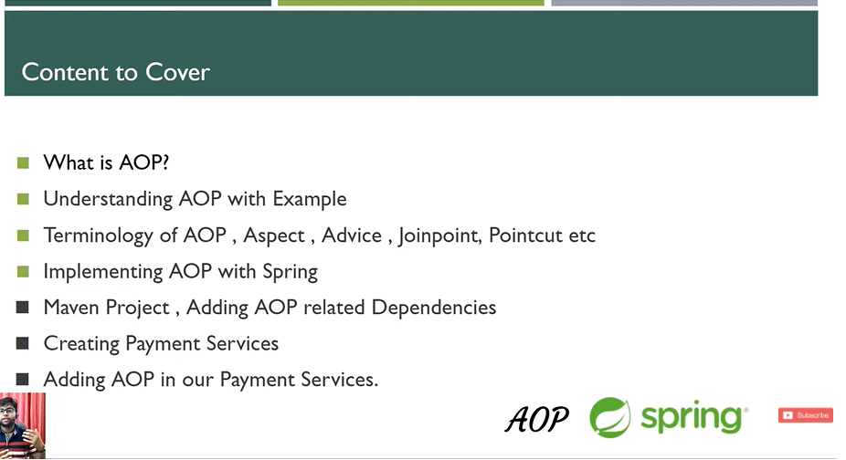

If we have many services and we use AOP we can modify and insert without disturbing and modifying those services
